​

**ITI Examination System**

Track: **Power BI Developer Track**

Supervisor:

Eng. **Rami Nagi**

Presented by:

**Mohamed Emad Mohamed**

**Mohamed Korani Mohamed**

**Nouran Mahmoud Yassin**

**Ahmed Magdy Abdelhafiz**

**Ahmed Ismail Okasha**

## **Project Overview**

Our Project, Examination System aims to automate the online exam process. This system provides an SQL-based database solution for exam-related data and generates reports for instructors and ITI staff.

The exam results can be used to identify areas that require improvement and to guide training and development efforts, and even we are conversant with online courses as well besides freelancing jobs to trace what students learned.

The examination system is an essential component of the assessment process, which helps ensure quality education. As such, educational institutions need to design examination systems that are fair, reliable, and valid, to ensure that students receive accurate and meaningful feedback on their learning progress.

The exams are generated randomly by a stored procedure called Exam_Generation, there is another procedure called Exam_Answer that is responsible for storing the students’ answers in a database, and finally, a procedure called Exam_Correction which is responsible for correcting the answers and calculating the students’ percentage in this exam.

Dashboards can be created to visualize the exam results, allowing instructors and individuals to track their progress toward mastery of the subject matter. The dashboards can provide detailed information about the student’s enrolment process till taking the courses to finish them with the final intake certificate qualify them to work in a fitting company, also presents the data from stored procedures to SQL Server Report Server that shows exams by each exam number.

## **Tools We Used**

* **Draw.io (online website).**

To design both Entity Relationship Diagram (ERD) & Database schema.

* **SQL Server Management Studio.**

For database implementation.

* **SQL Server Reporting Service and Visual Studio.**

For implementing Reports.

* **Power BI Report builder:** paginated report designed for creating a report definition that specifies what data to retrieve.
* **Microsoft Power BI Desktop.**

For designing Dashboards.

## **Business Case**

We are developing an online examination system, where students can take many exams on different topics and get their exam percentage instantly.

**Main Entities Overview:**

* **Branch:** Our system centralizes the management of branches across different locations, each with a unique identifier, name, and location. Additionally, branches are led by competent managers and offer various educational tracks facilitated by instructors.
* **Student:** Students are the core beneficiaries of our system, each identified by personal details including name, contact information, gender, and age. They are affiliated with specific faculties, acquire certificates, and participate in rounds or intakes. Moreover, students engage in track enrollment, examination-taking, and question-answering activities.
* **Instructor:** Our system empowers instructors with the necessary tools to effectively manage educational tracks and courses. Instructors possess essential information such as contact details, qualifications, and teaching experience. Additionally, they oversee the delivery of courses, evaluate student performance, and provide mentorship to facilitate academic growth.
* **Tracks:** Educational tracks represent specialized learning paths designed to equip students with industry-relevant skills and knowledge. A designated instructor manages each track and encompasses a cohort of students, courses, and graduates.
* **Courses:** Courses form the building blocks of educational tracks, offering structured learning experiences on specific subjects. They are delivered by instructors and cover various topics, assessments, and evaluations to gauge student proficiency.
* **Exams:** Examinations serve as pivotal assessments within courses, enabling students to demonstrate their understanding and competence. Exams are characterized by unique identifiers, names, dates, levels, durations, and full marks, with each exam comprising multiple questions.
* **Questions:** Questions are integral components of exams, featuring textual prompts, correct answers, difficulty levels, and types (e.g., multiple-choice, true/false). They are associated with specific courses and exams, allowing for comprehensive assessment across various subjects.

## **IMPLEMENTATION LIFE CYCLE**

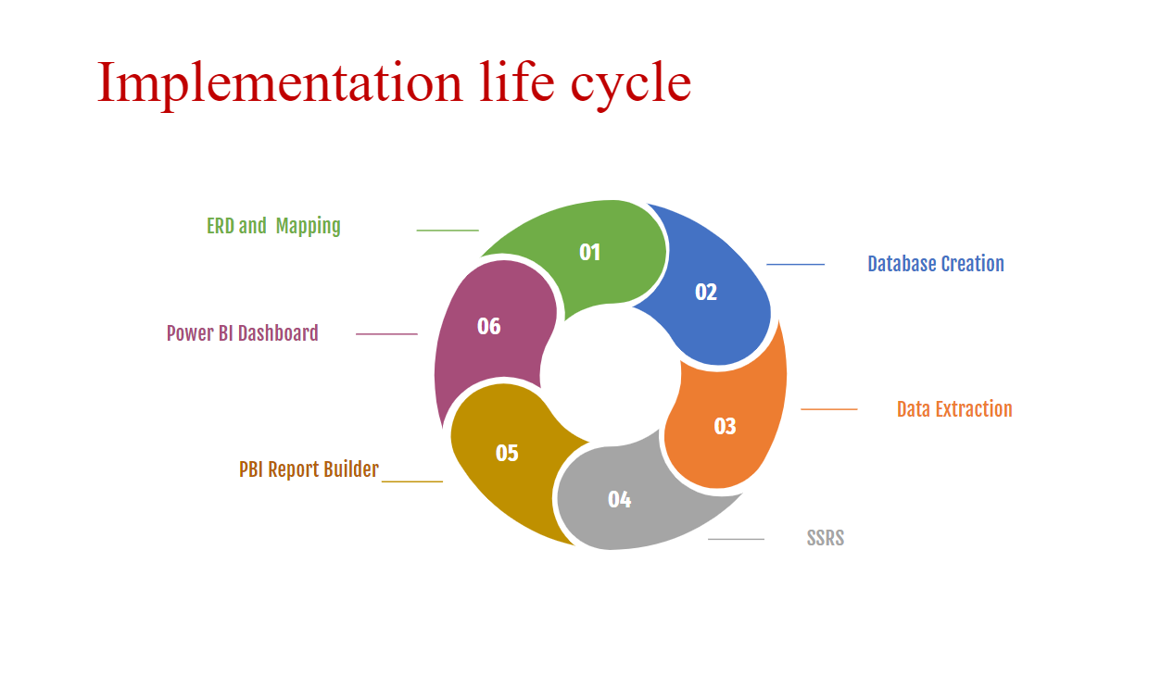**The implementation life cycle** is an iterative process needed to ensure the system meets the requirements that outline the phases a system goes through, from entity relationship diagrams to reports and interactive dashboards.

**ERD& Mapping:** In this phase, we created detailed design specifications for the entity relationship diagram, and database schema, and developed dashboard perspectives.

**Database creation:** Here, we coded the database schema, integrated the components into a working system, and tested the system to ensure it can manage exams and answers.

**Data Insertion:** Inserting data into the database for generating reports in Power BI Desktop, SQL Server Report Service, or Power BI Report Builder involves querying the database, saving the data as a CSV file, and importing the data into the reporting tool, or directly connecting to the database from the reporting tool and extracting the data.

**SSRS:** SQL Serverreport server to present the data from stored procedures to SQL Server Report Server to show the targeted report like different courses, topics, and exams.

**Power BI Dashboard:** to provide valuable insights into the department, instructor, student performance, and exam results, helping instructors make informed decisions about how to improve the intake quality support more student learning through online courses, and do more practice by freelancing jobs.

**DATABASE DESIGN (ERD)**

Examination system ERD includes entities such as Intake, Branch, Track, Department, Students, Questions, Feedback, Exams, Courses, Topic, and their relationships to each other.

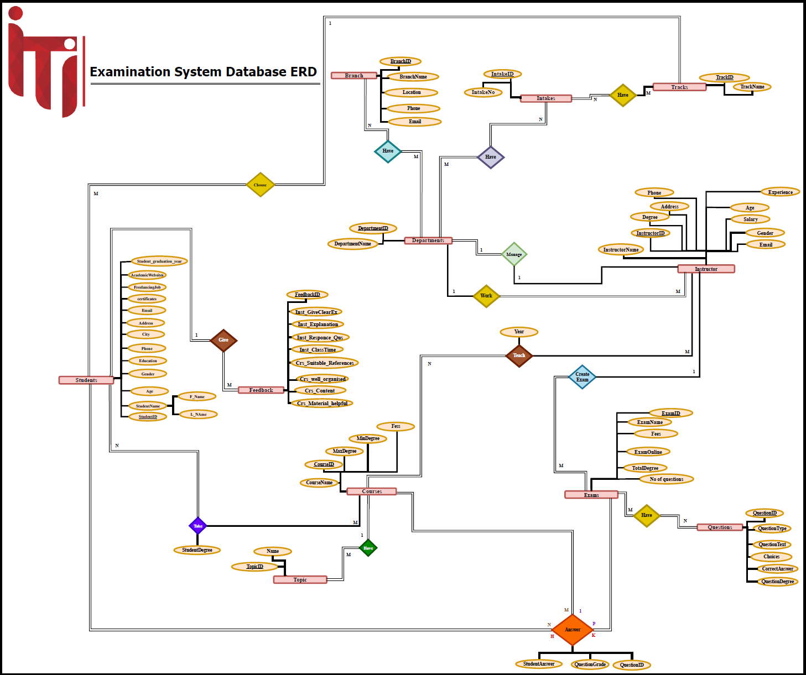

**DATABASE DESIGN (MAPPING)**

Mapping in the examination system refers to the process of creating a correspondence or association between different entities or attributes in the system needed to implement in the SQL Server Management Studio.

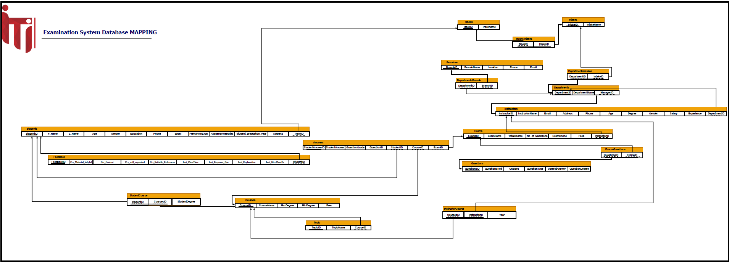

**IMPLEMENTATION**

Creating a database for an examination system typically involves defining tables to store information about the Intake, Branch, Track, Department, Students, Questions, Feedback, Exams, Courses, and Topics. Once we defined the table schema, we populated the tables with data.

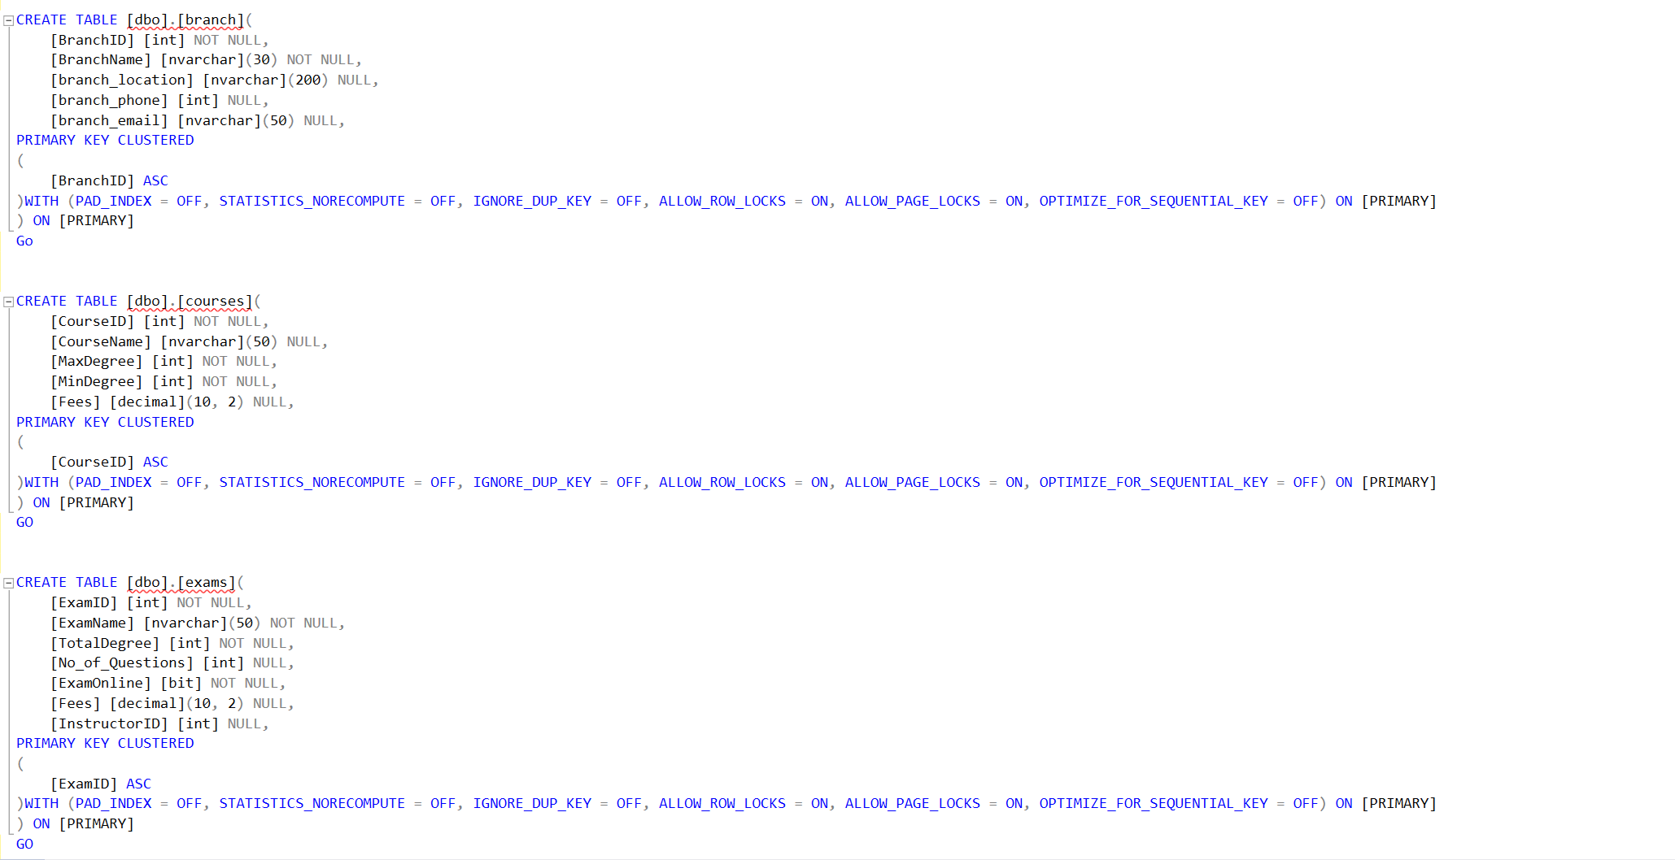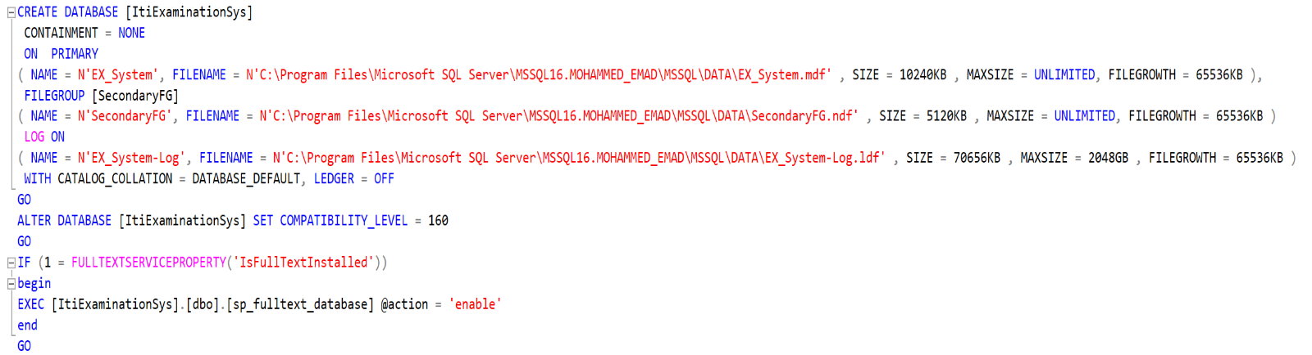

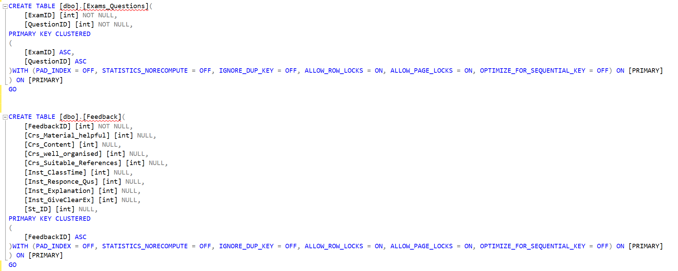

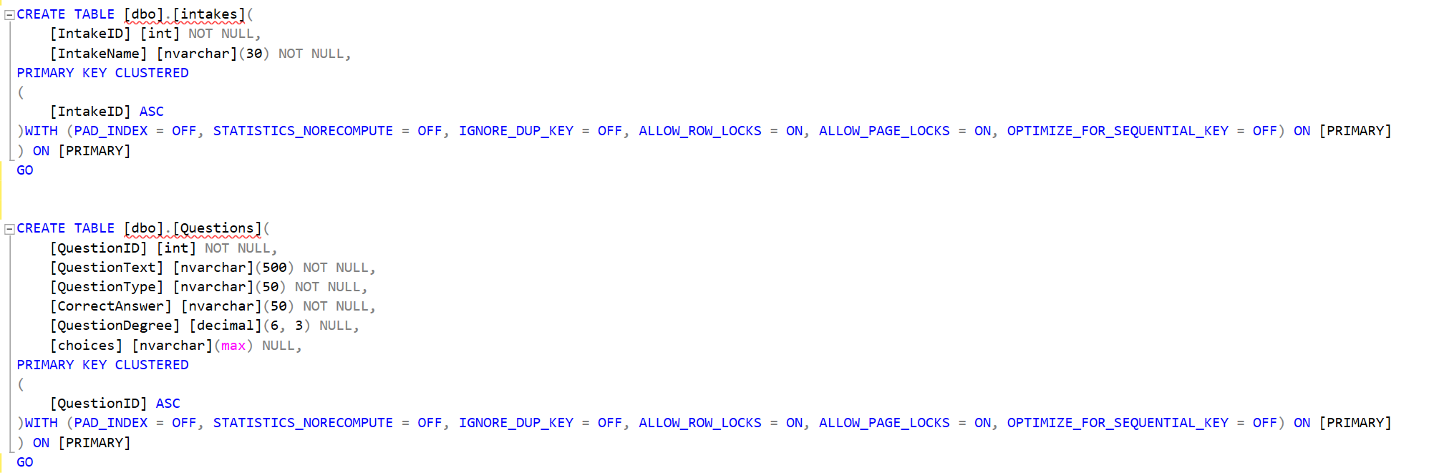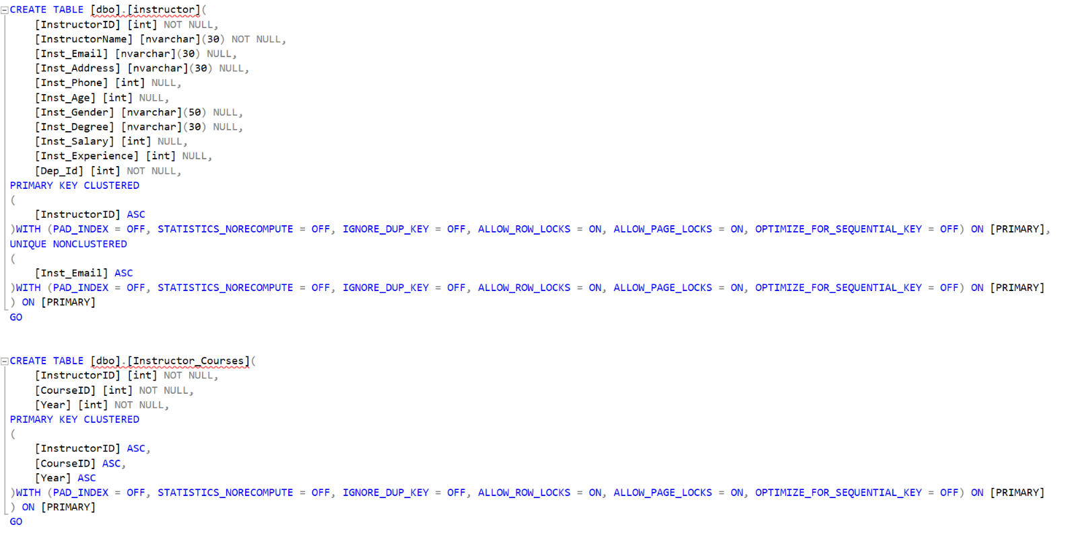

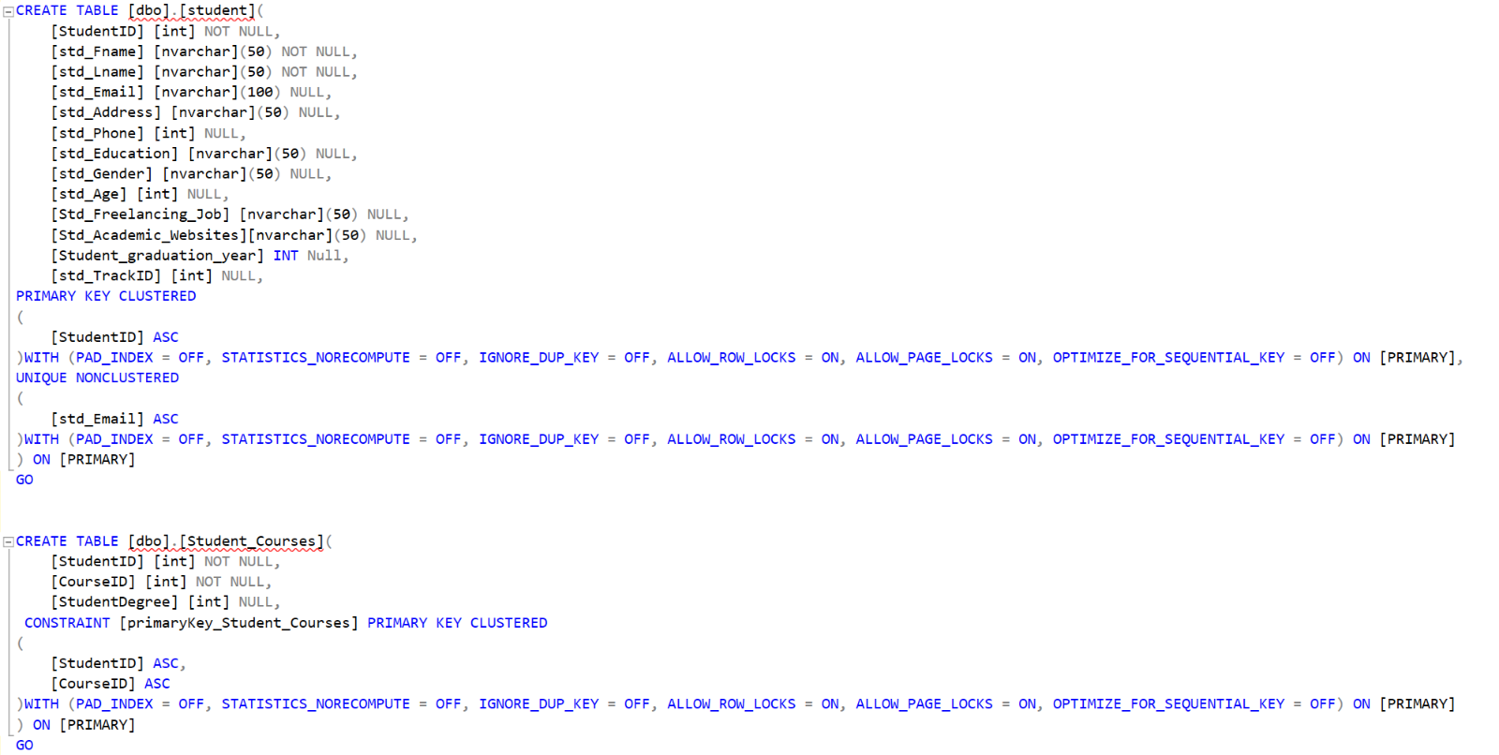

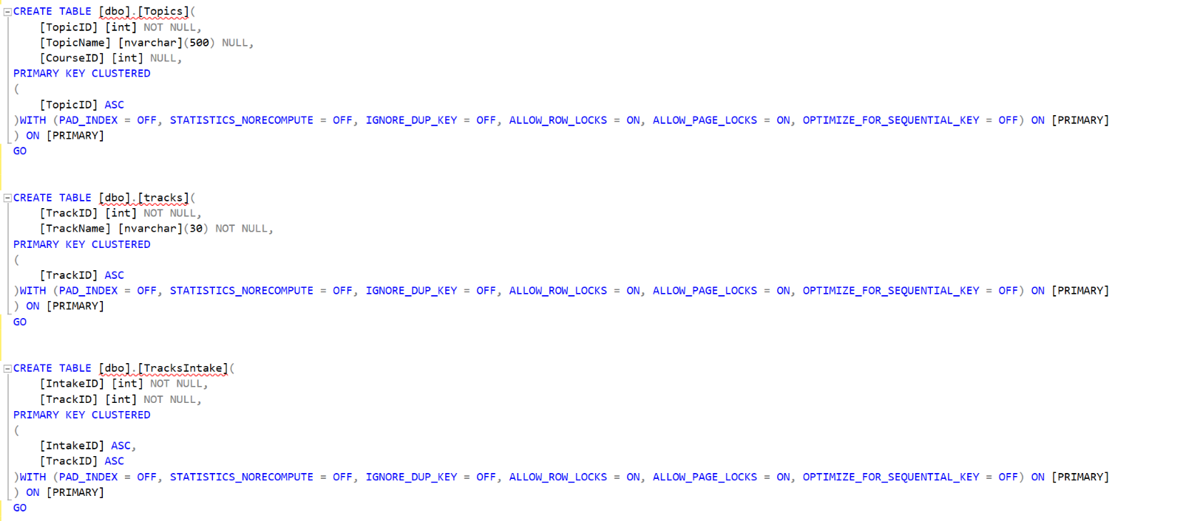

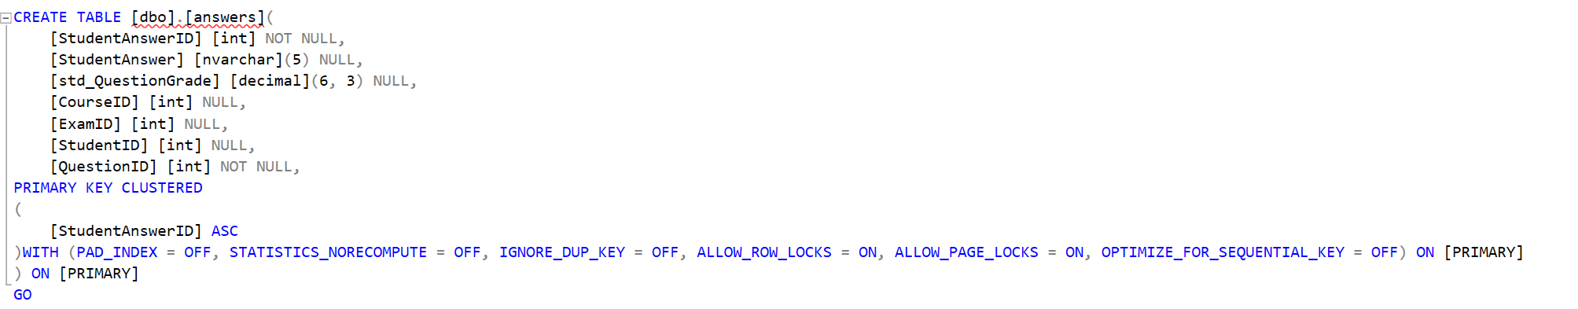

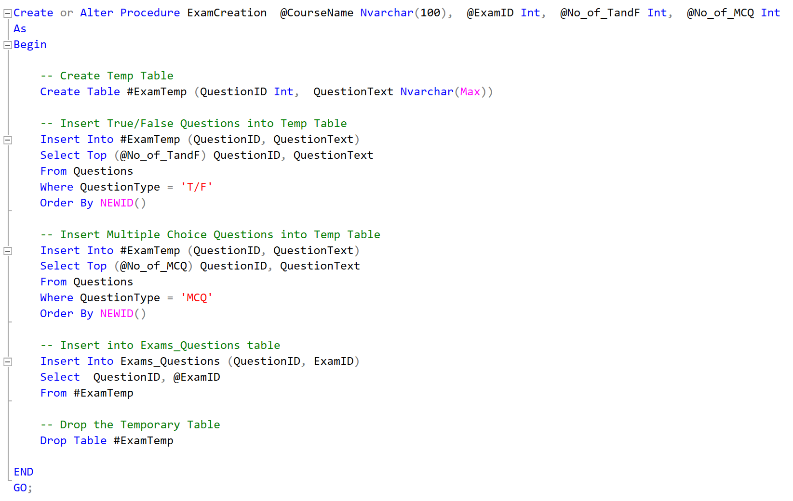**ExamCreation** is a stored procedure created to get @CourseName, @ExamID, @No_of_TandF, @No_of_MCQ, then choose 10 questions randomly 3 of them T/F questions and the other 7 are MCQ.

After that save the student Answers in **InsertStudentAnswer** stored procedure which gets @ExamID, @CourseID, @StudentID, @QuestionID, @StudentAnswerID, and @StudentAnswer as input

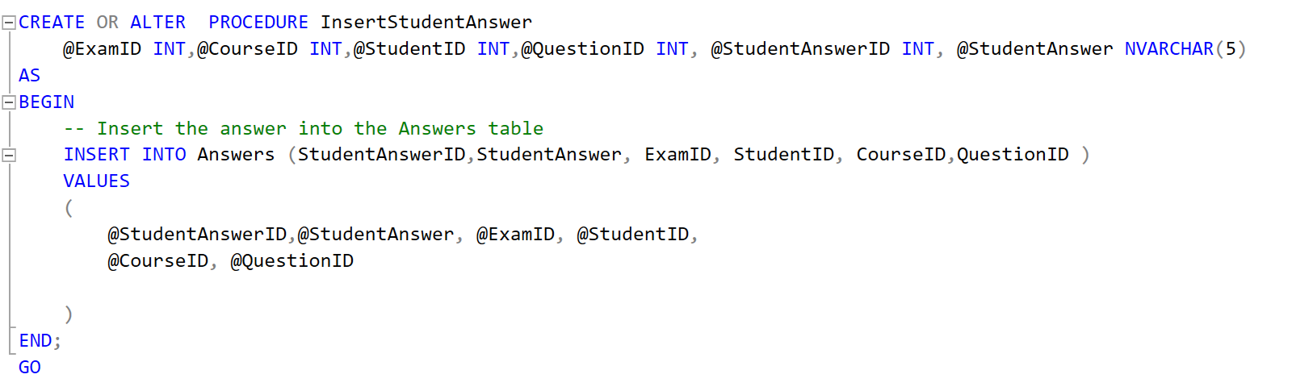

The last Stored procedure in the Exam Process is **ExamCorrection** which gets @StudentID, @ExamID, and @CourseID as input and compares the saved answers with model answers,

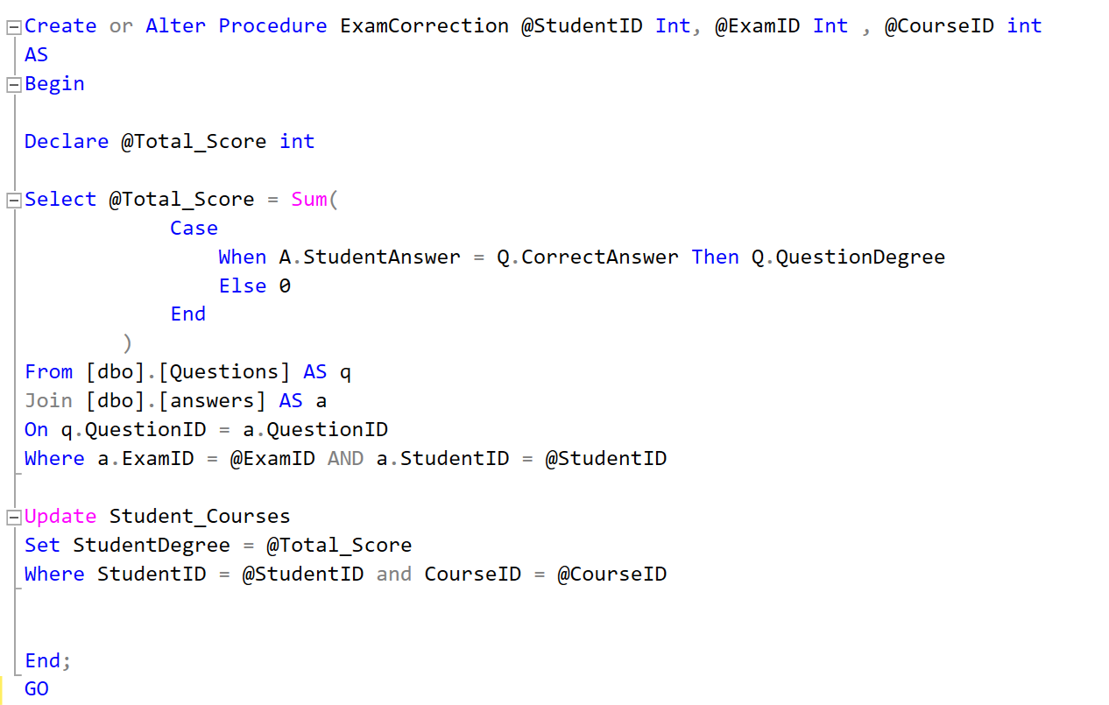and Sum the total score if the saved answer is correct.

Basic Stored Procedures for Tables (Insert, Select, Update, Delete):-

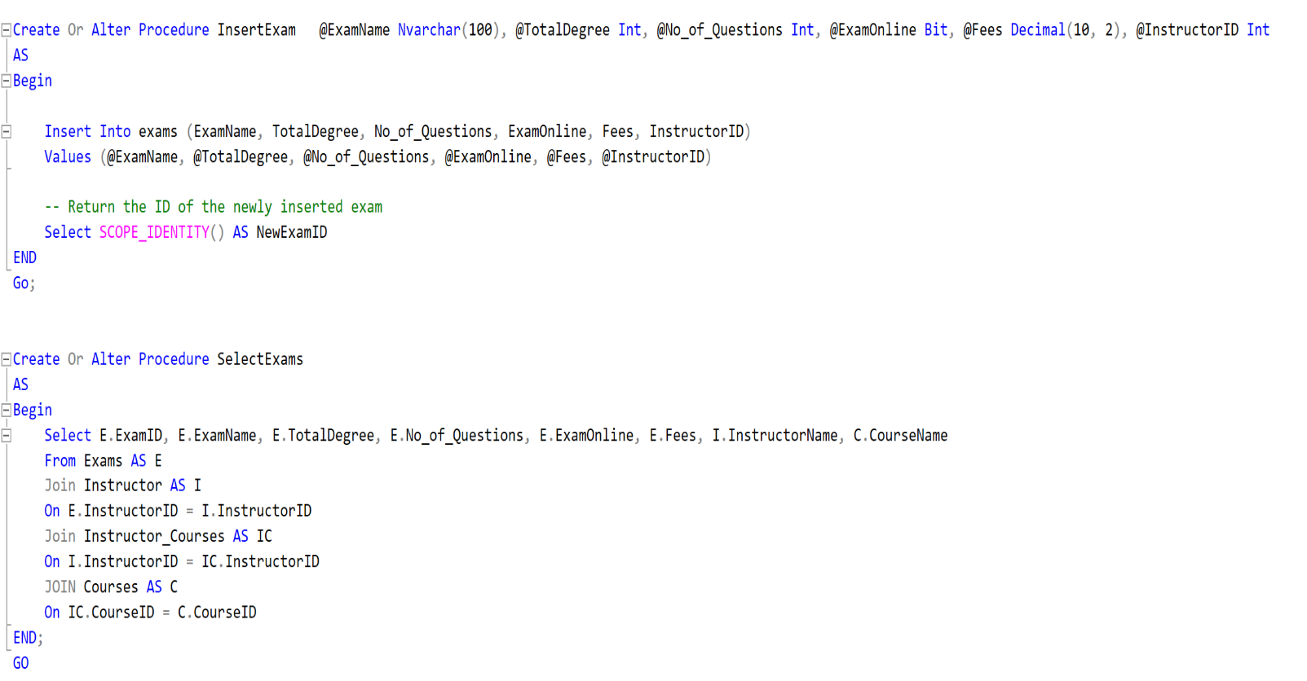 4 Stored Procedure for Exams:

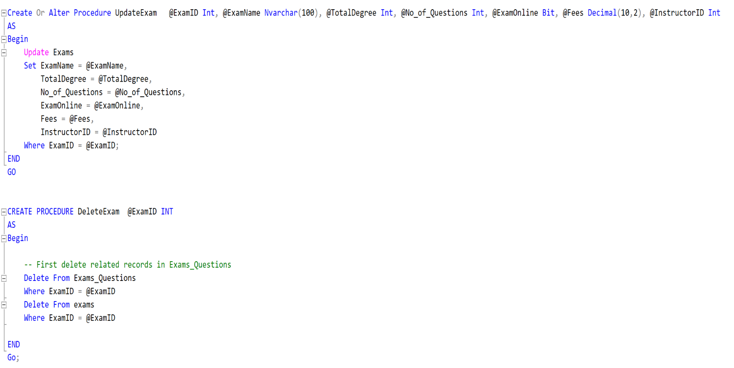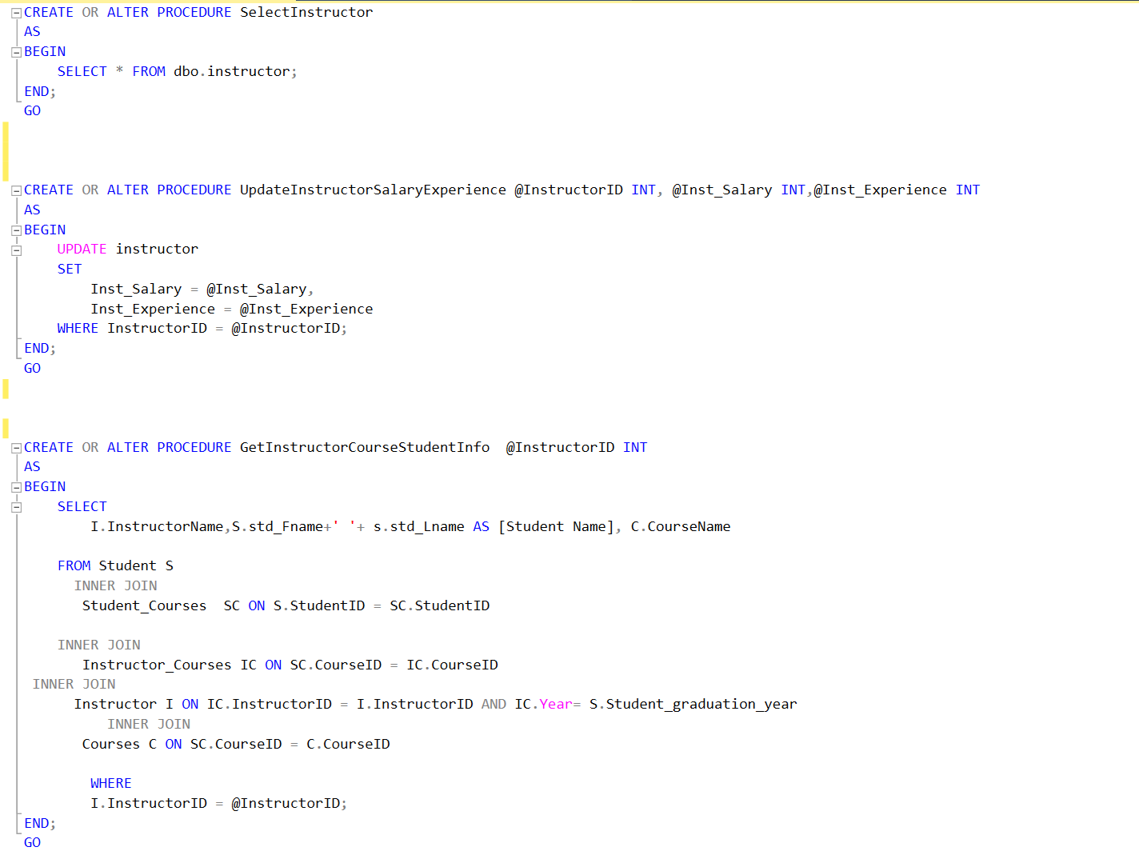 4 Stored Procedure for Exams:

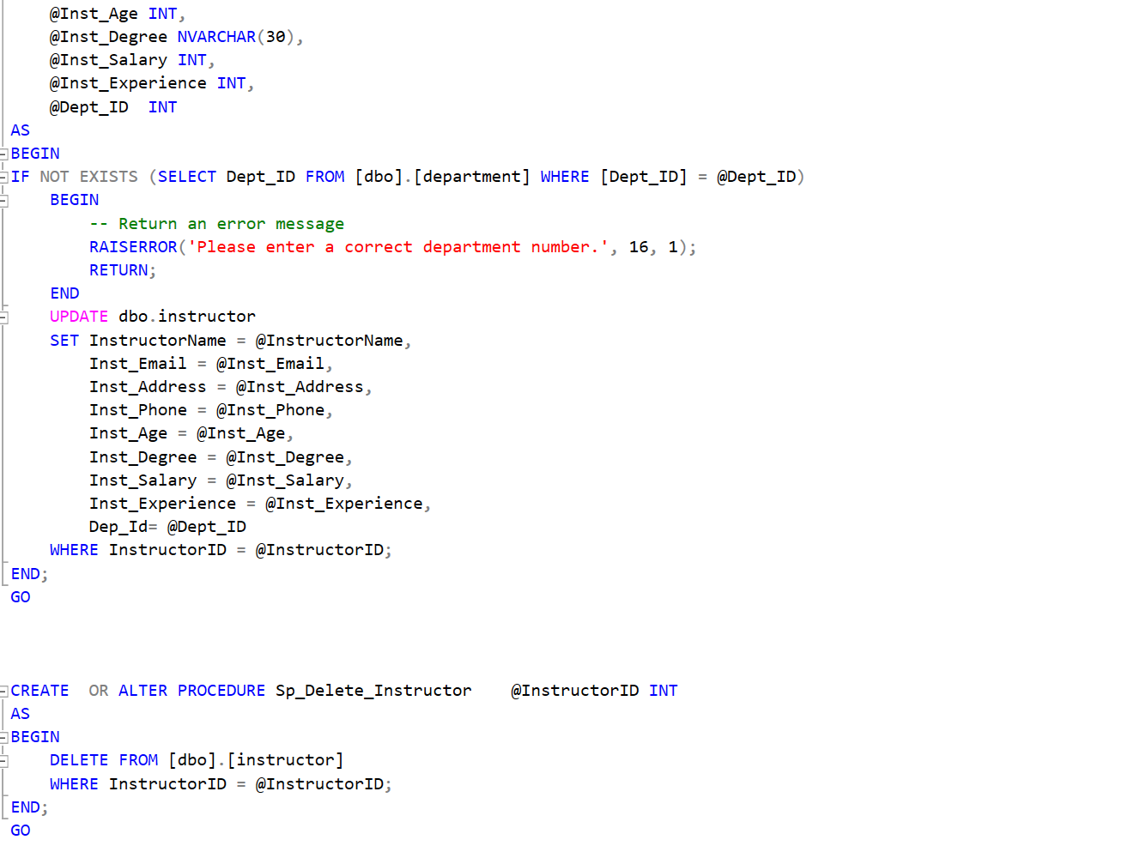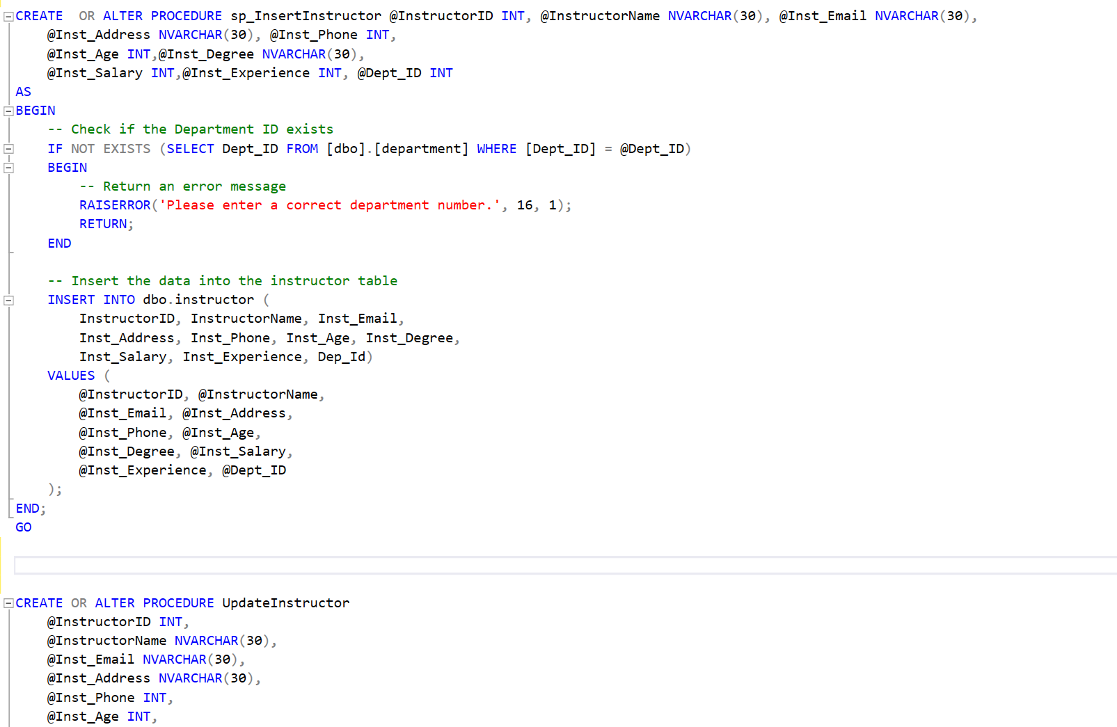

4 Stored Procedure for Department:

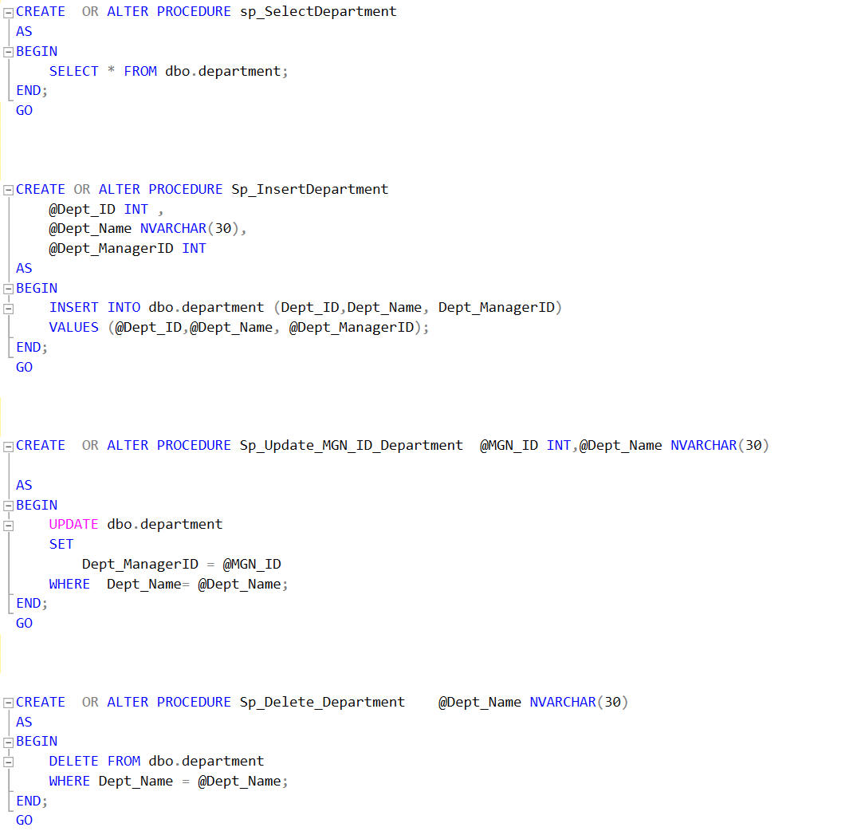

Stored Procedure to select Department Details With Courses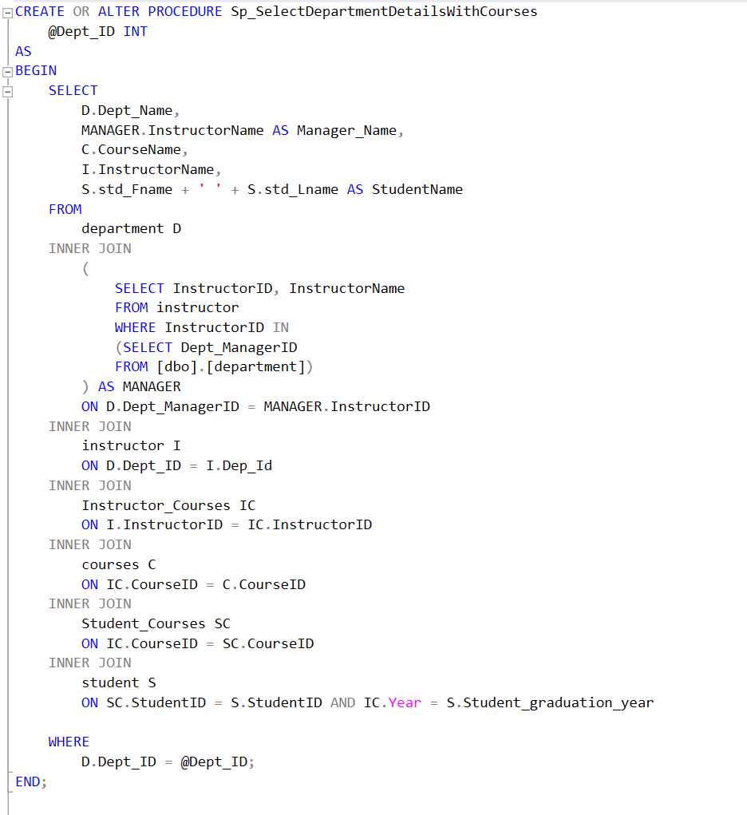

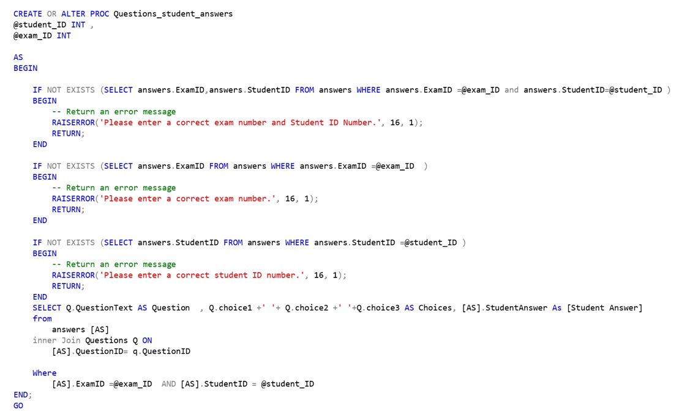Stored Procedure takes the exam number, and the student ID returns the Questions in this exam with the student's answers.

4 Stored Procedure for Student:

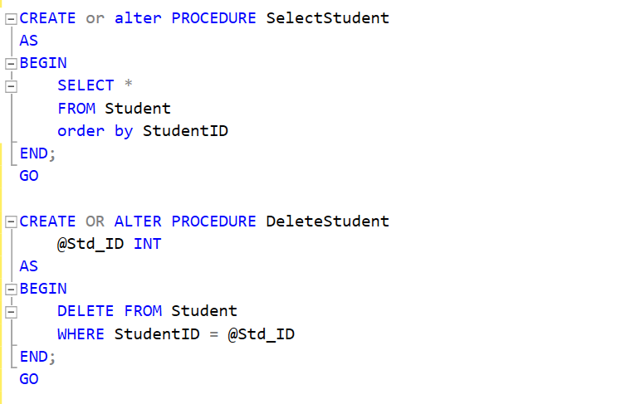

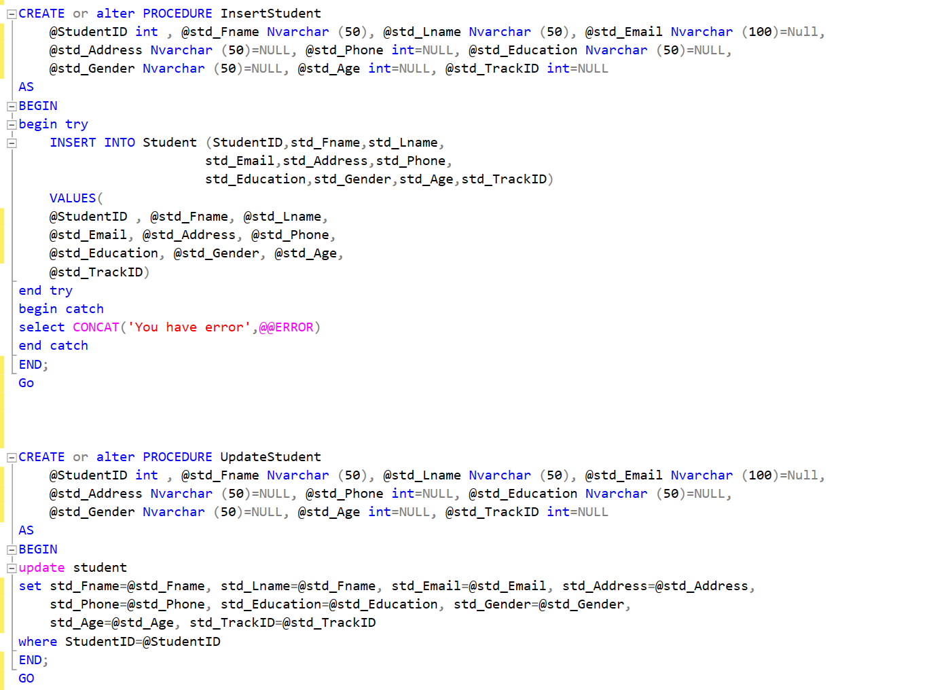

4 Stored Procedure for Track:

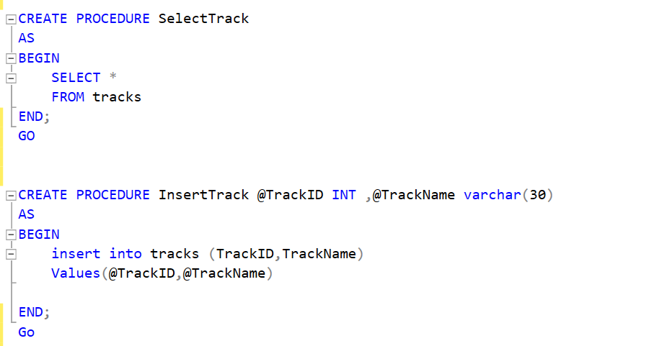

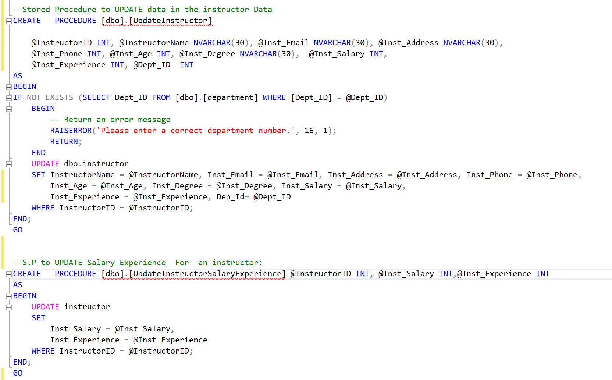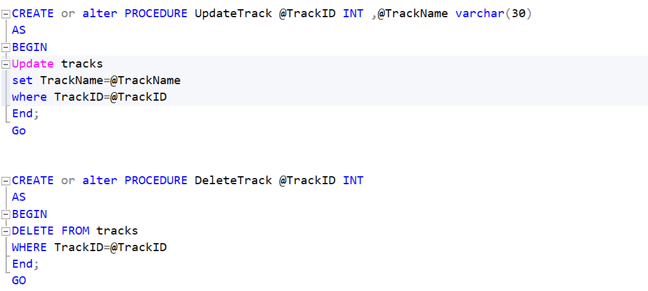

4 Stored Procedure for Instructor:

**SSRS Reports**

1. 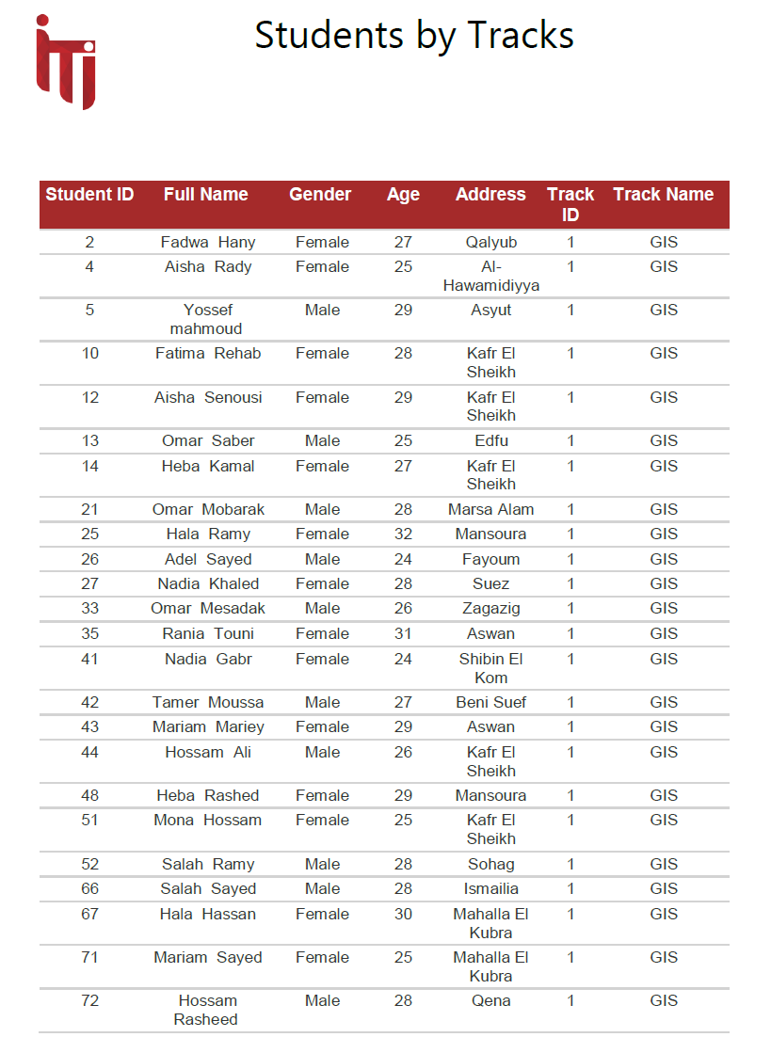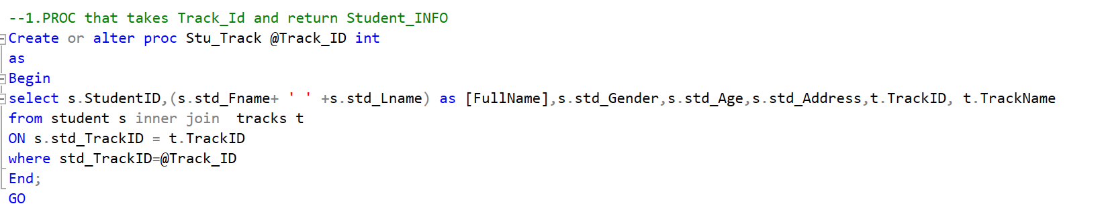First Report that returns the student's information according to Track ID.
2. 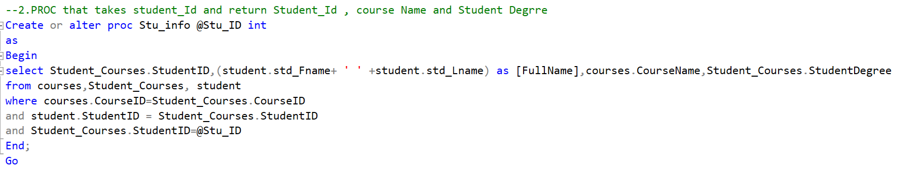Second Report that takes the student ID and returns the student's grades in all courses.

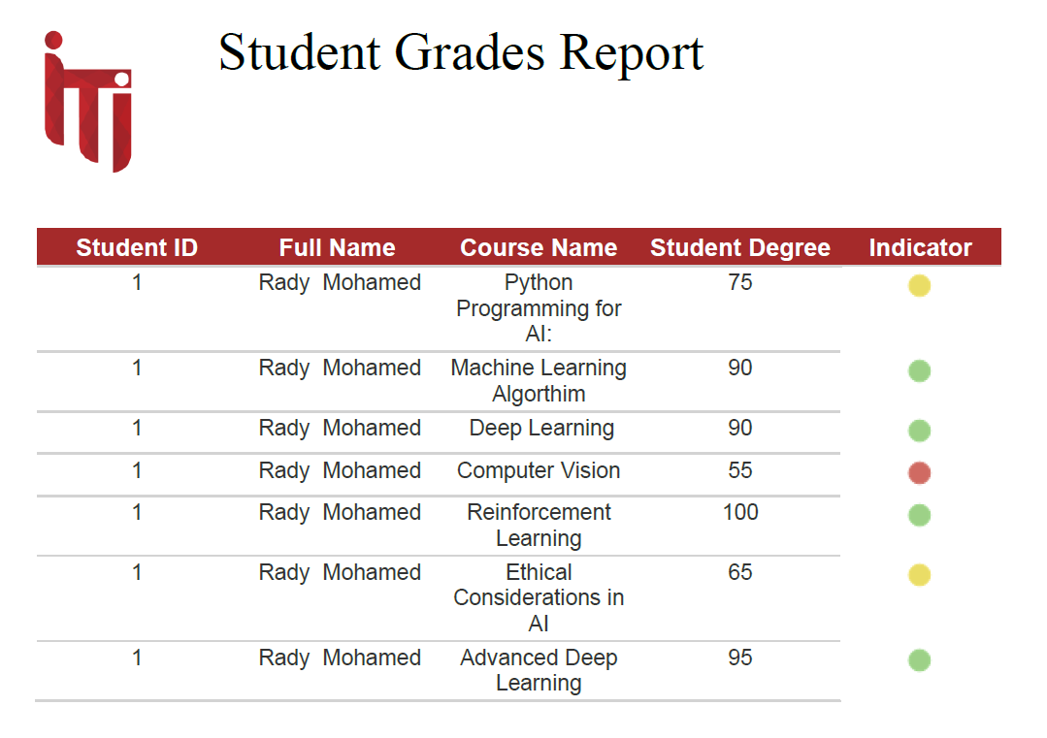

1. 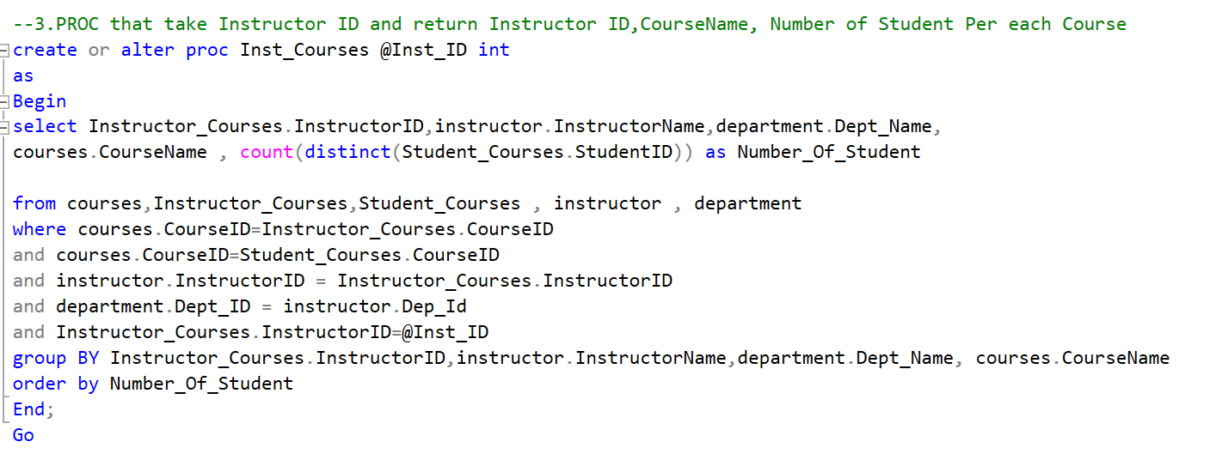Third Report that takes Instructor ID and return Instructor ID, CourseName, Number of Student Per each Course.

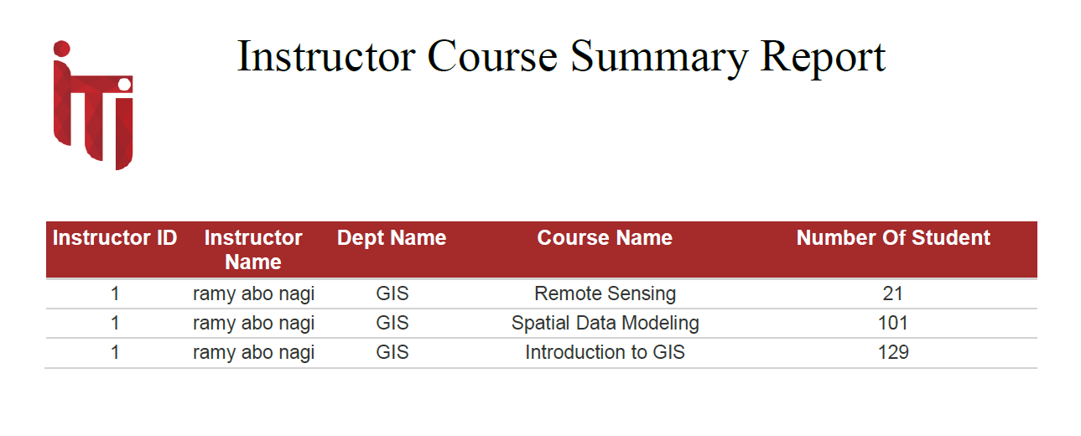

1. Fourth Report takes course ID and returns its topics.

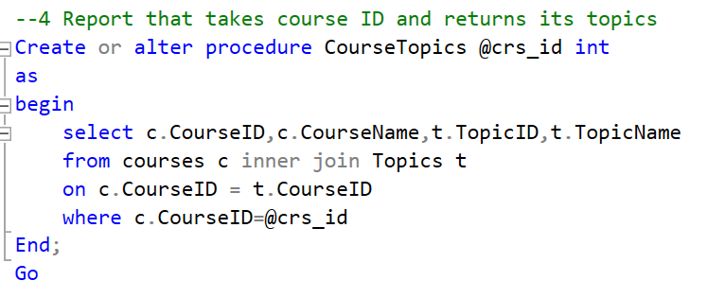

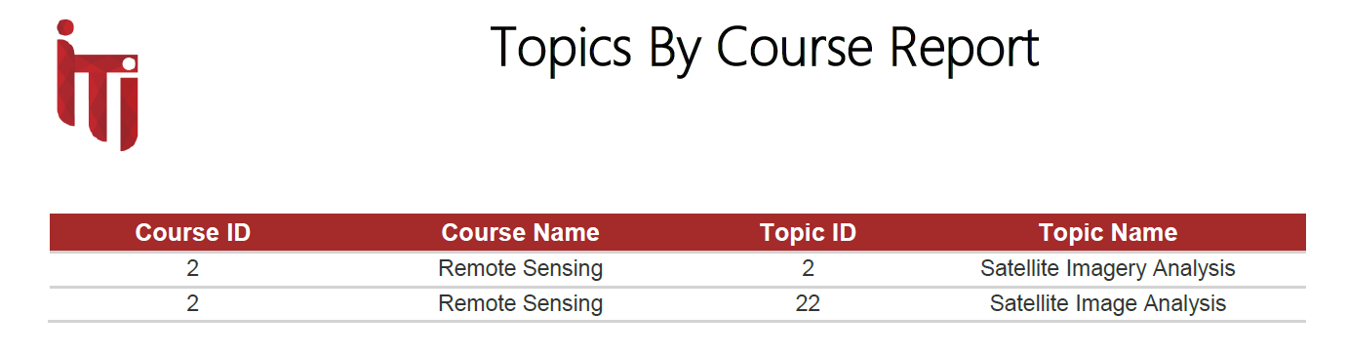

1. 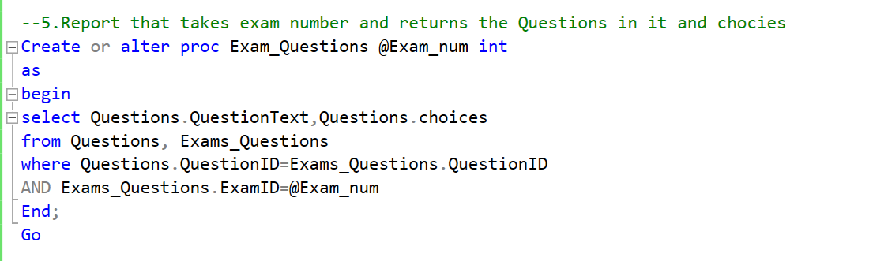Fifth Report takes exam number and returns the Questions and choices.

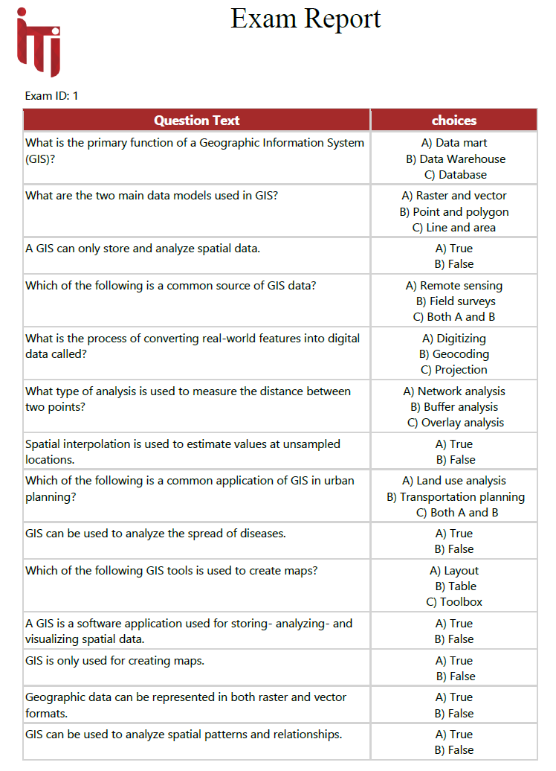

1. 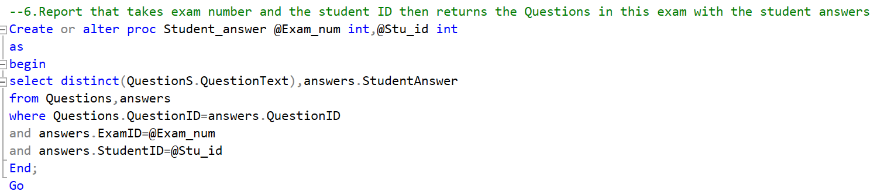Sixth Report takes the exam number, and the student ID returns the Questions in this exam with the student's answers.

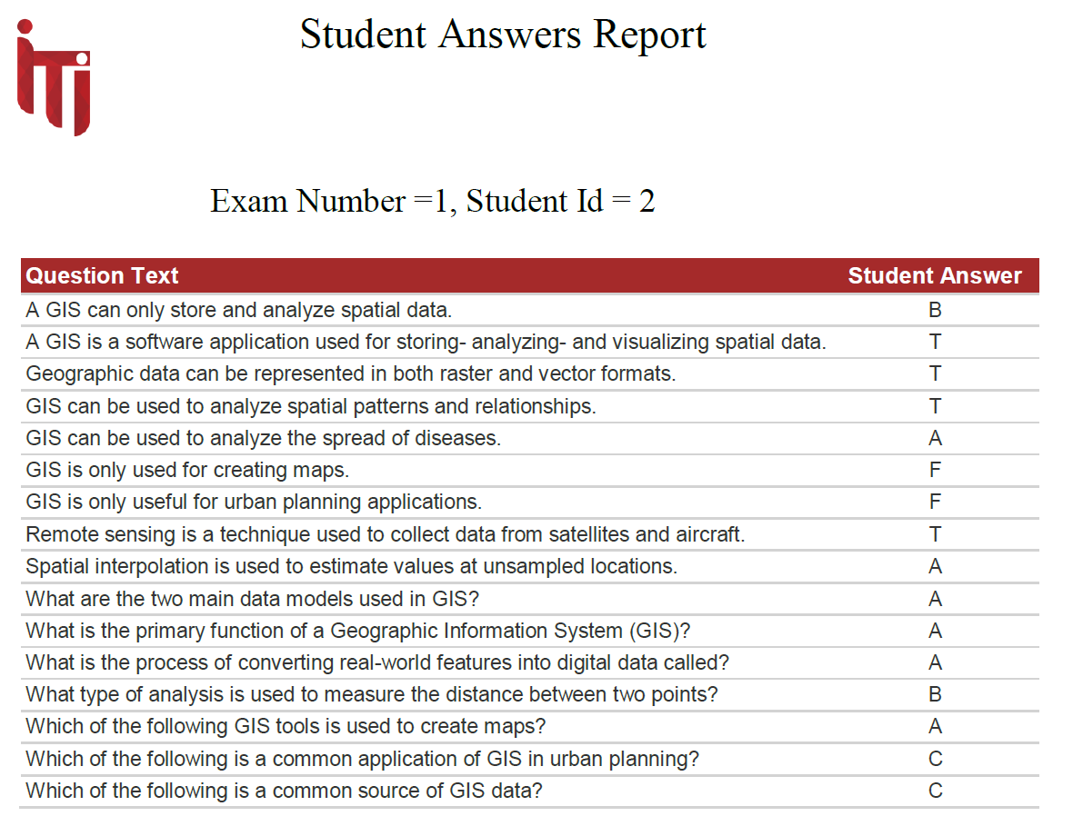

**Data warehouse design**

**-Data warehouse designed using star schema with one fact table and 8 dimension tables using sql server and SSIS for creating packages .**

**Star schema**

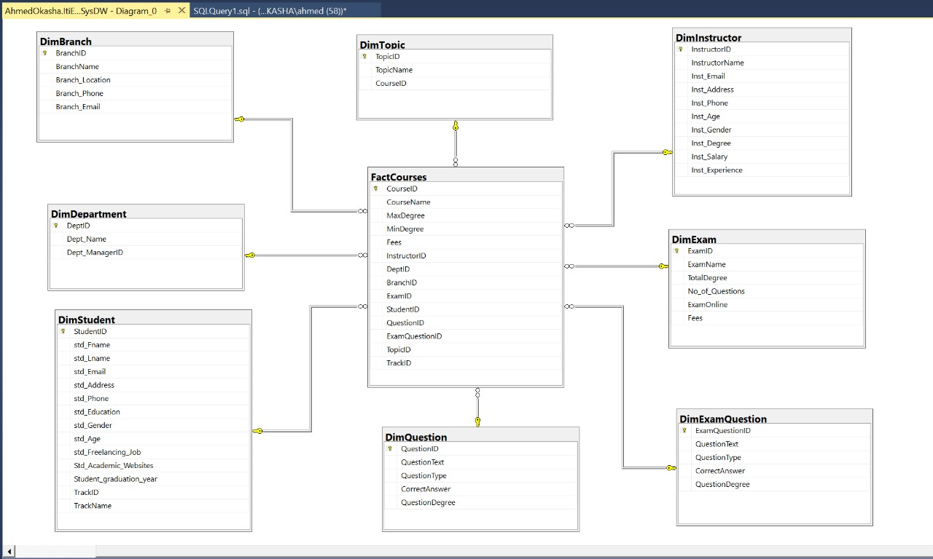

**SSIS packages for dimensions and fact tables:**

**Fact table (courses)**

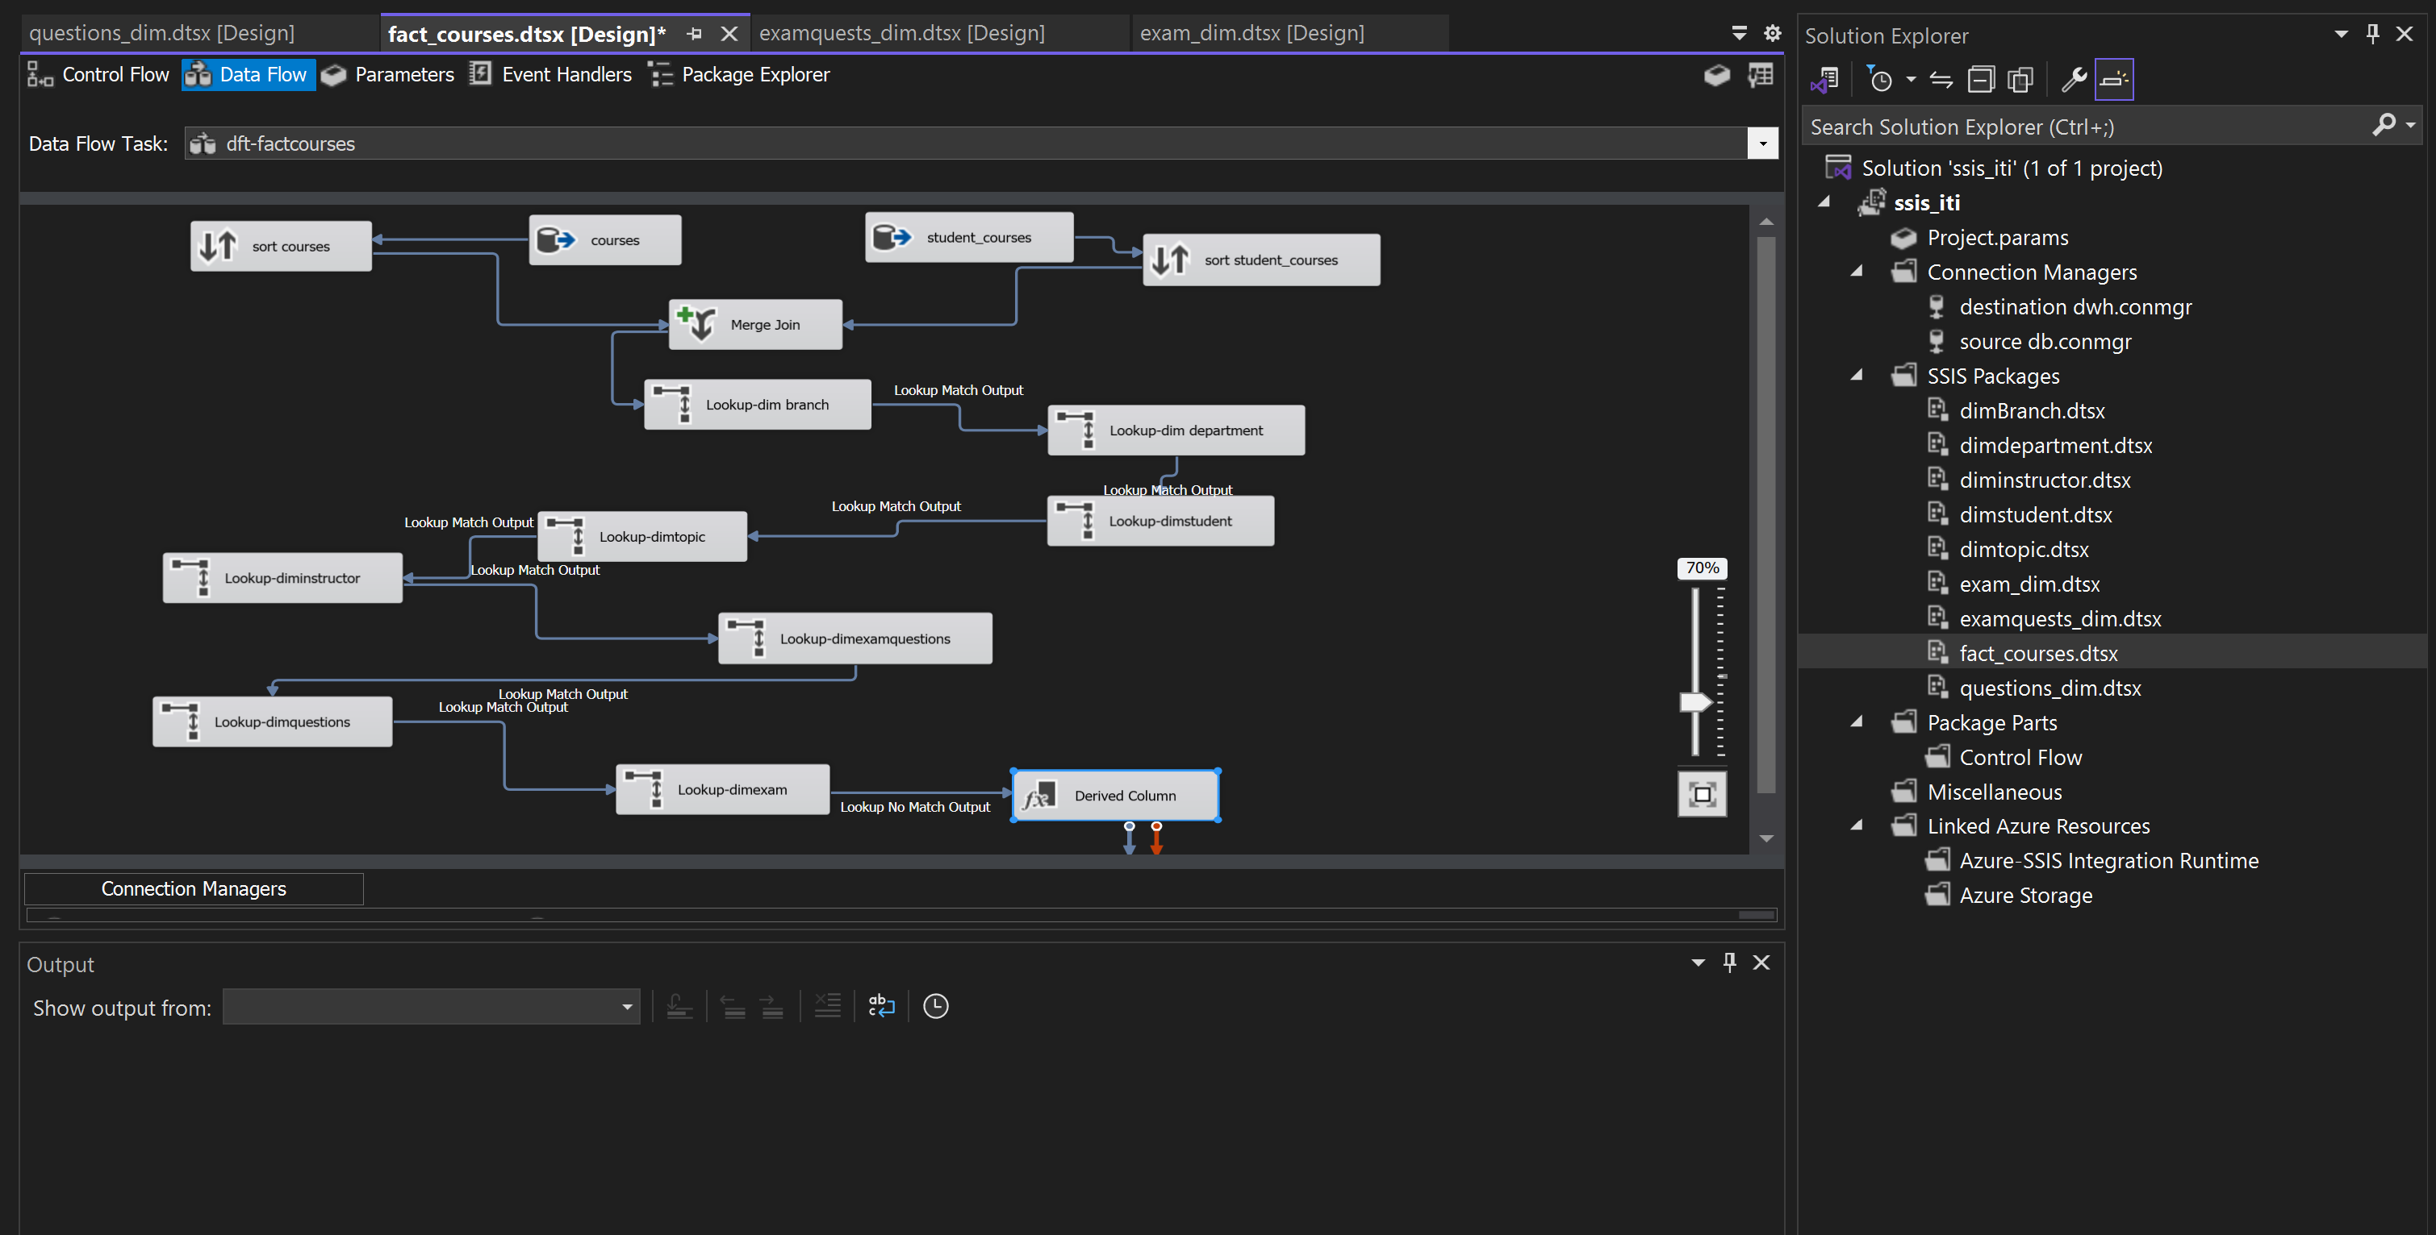**Dimension tables:-**

**1-branch**

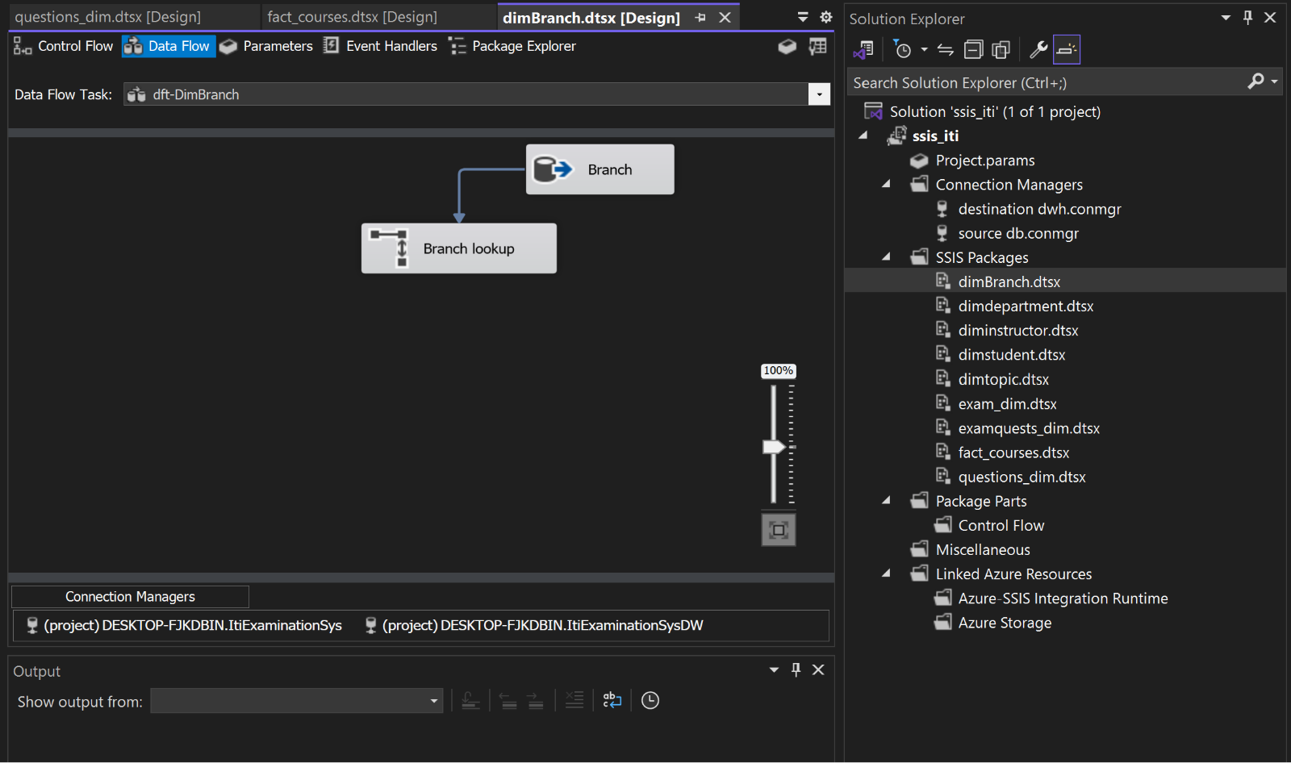

**2-department**

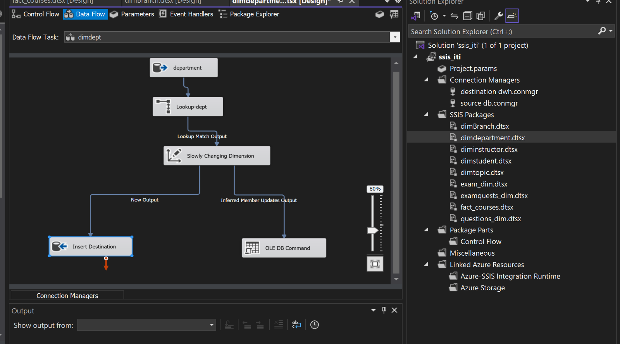

**3-exam**

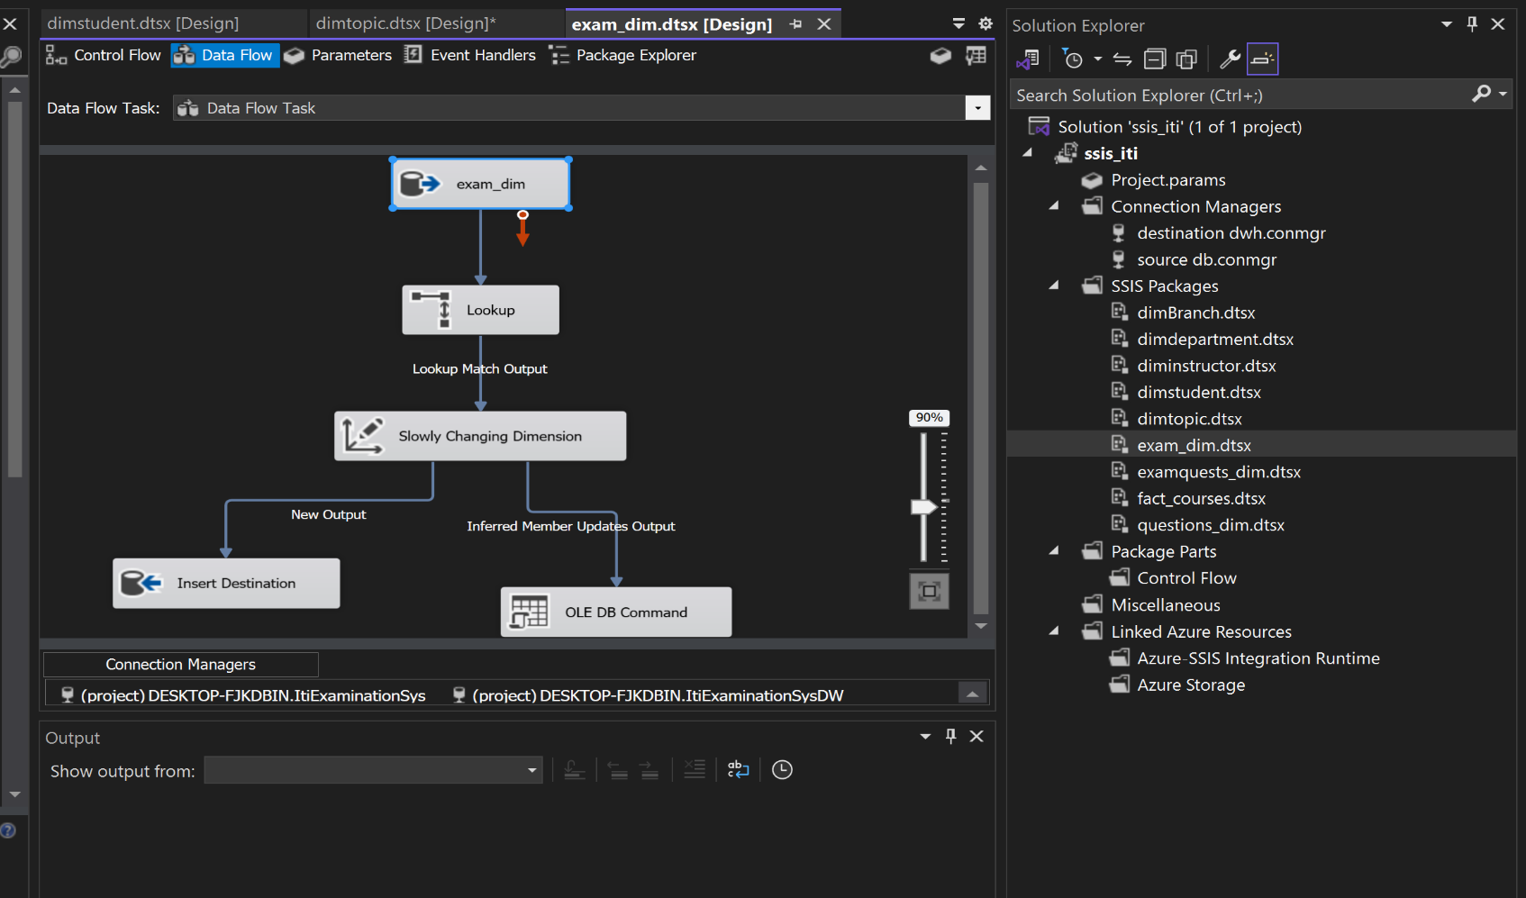

**4-examquestion**

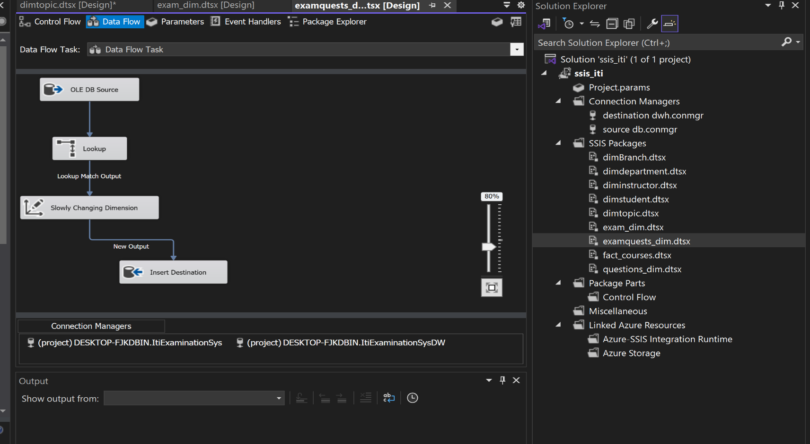

**5-instructors**

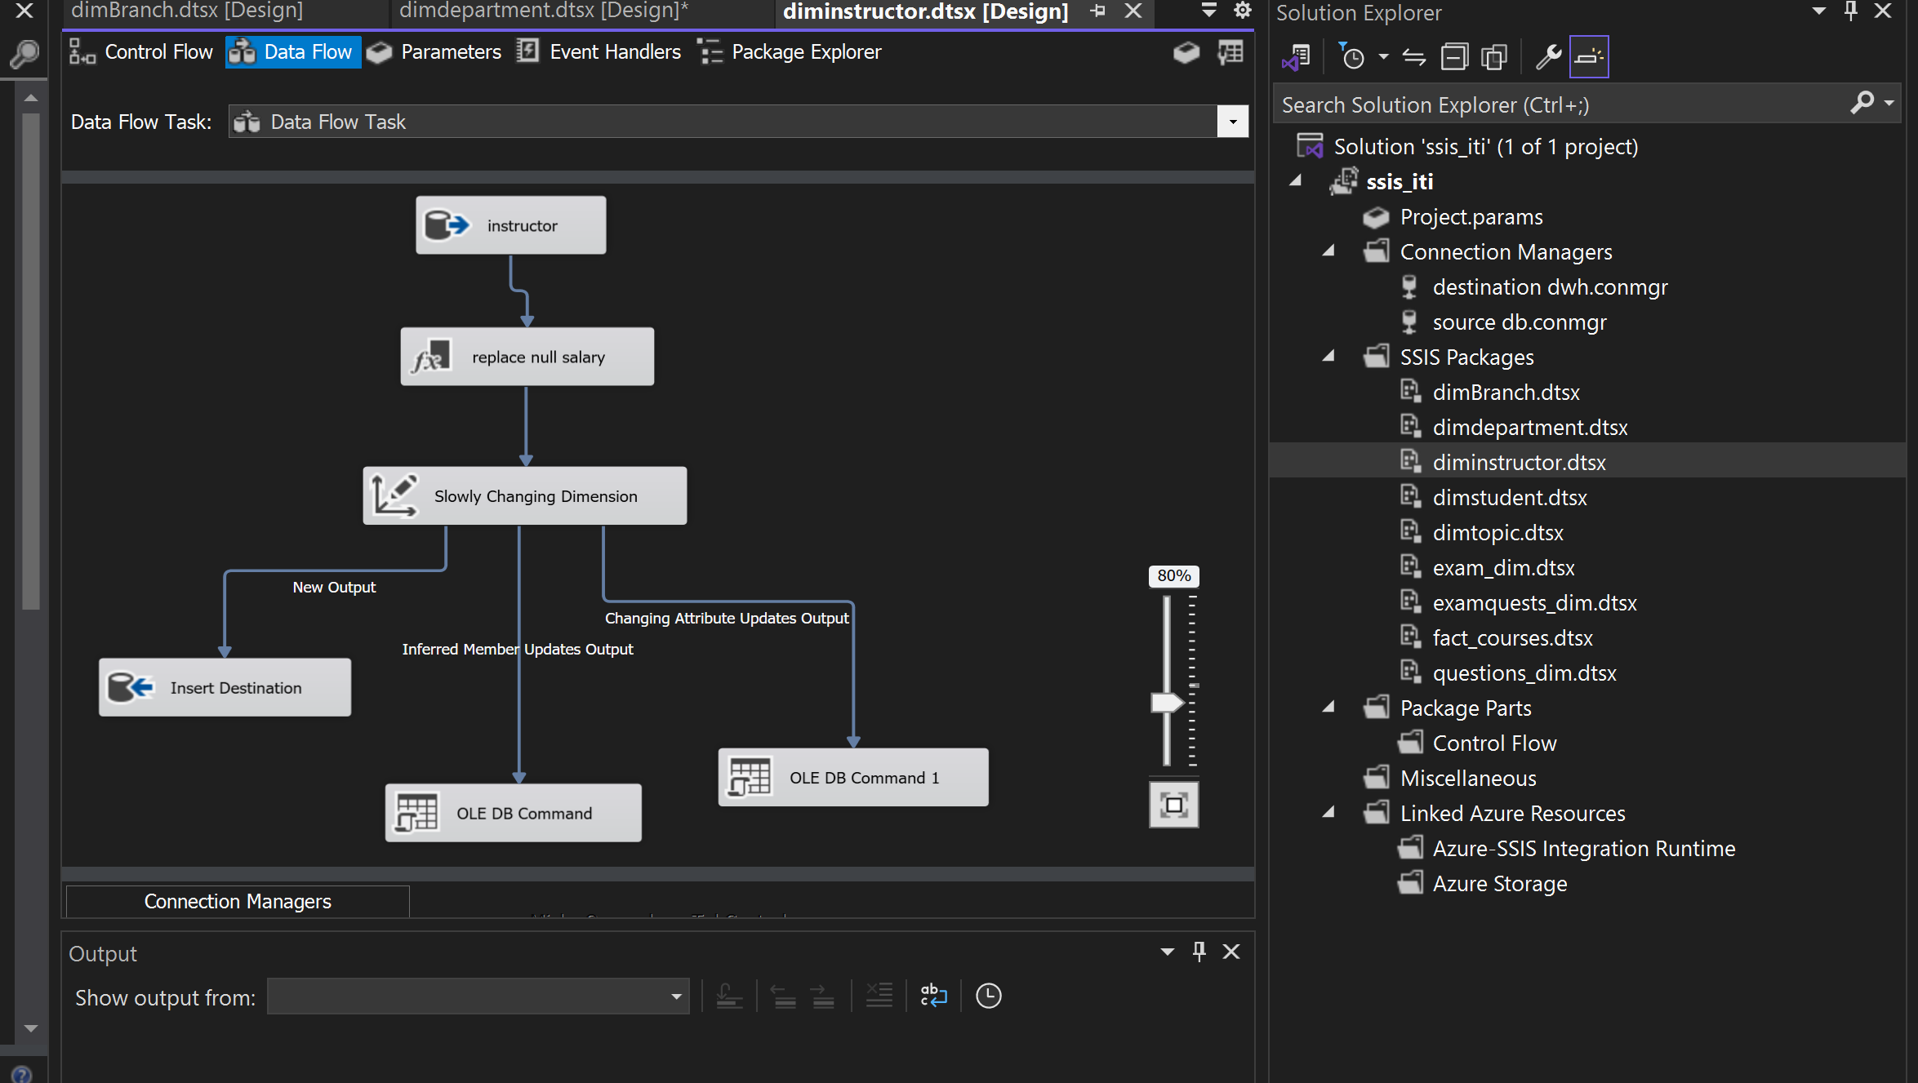

**6-questions**

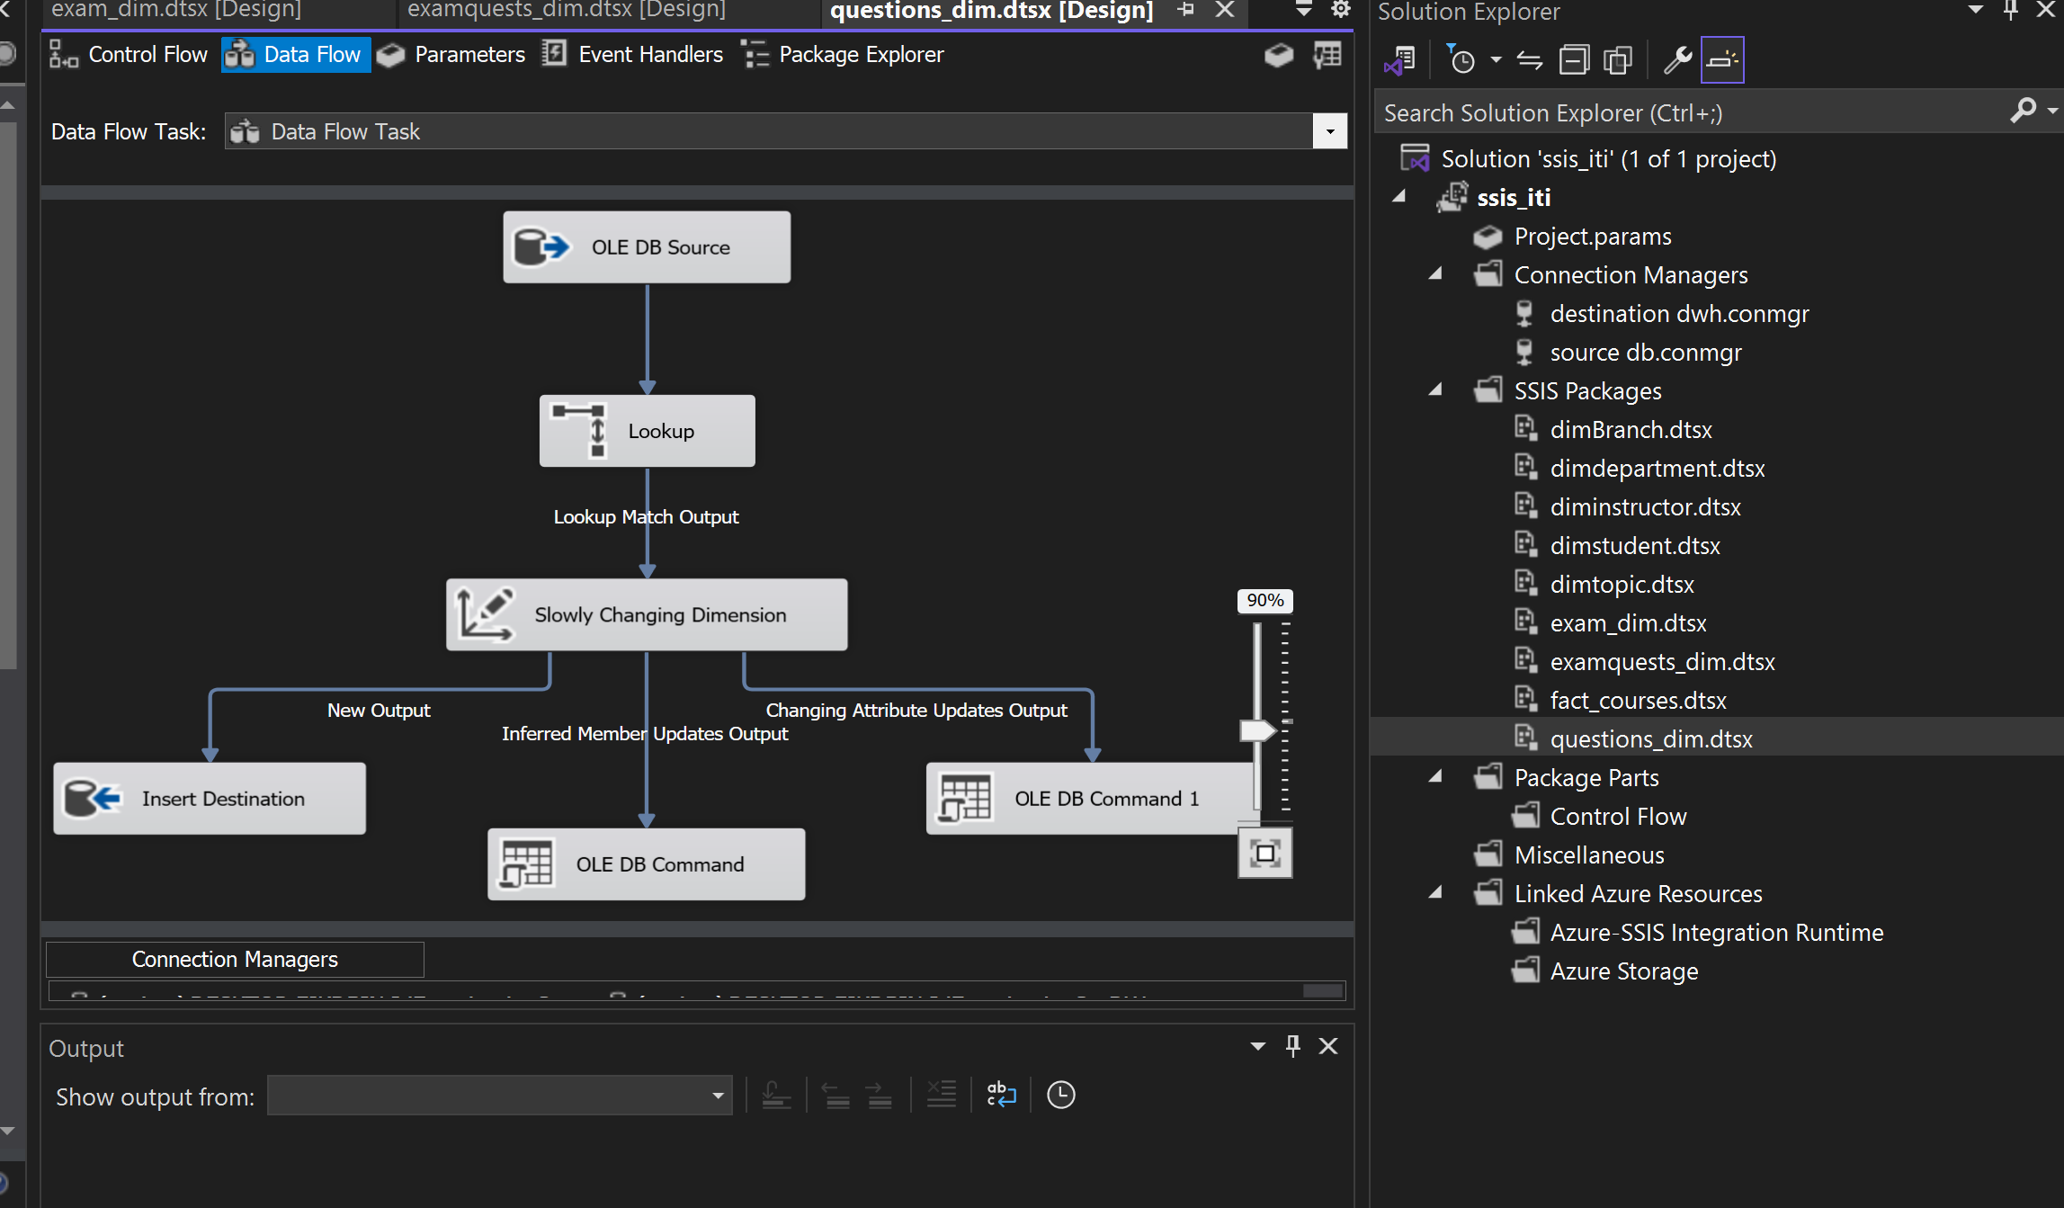

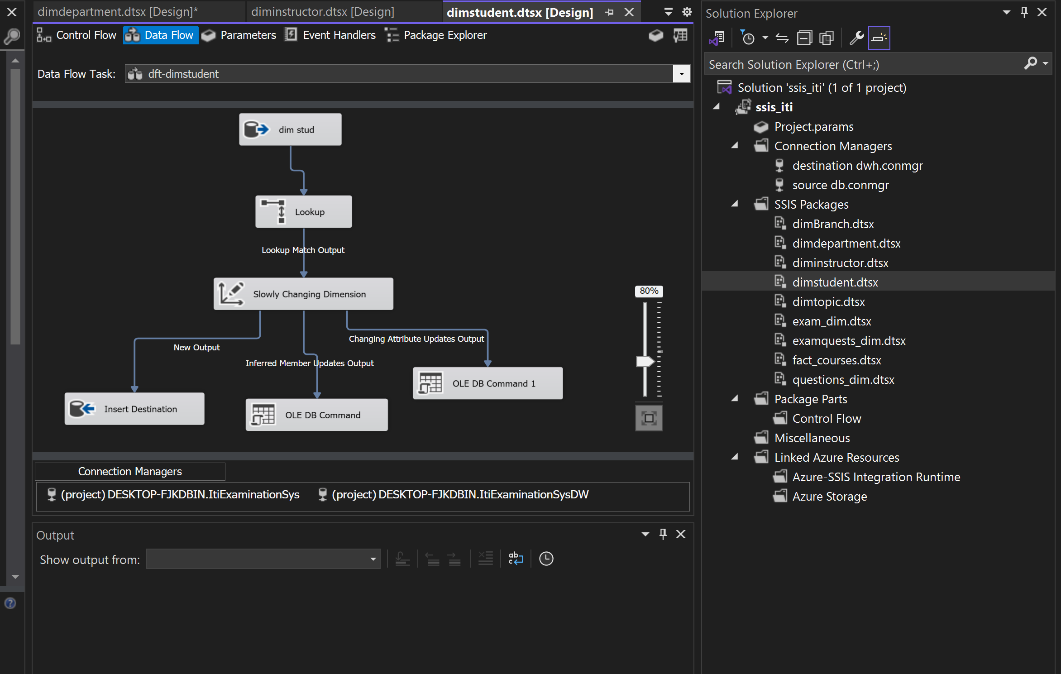**7- student**

**8-topic**

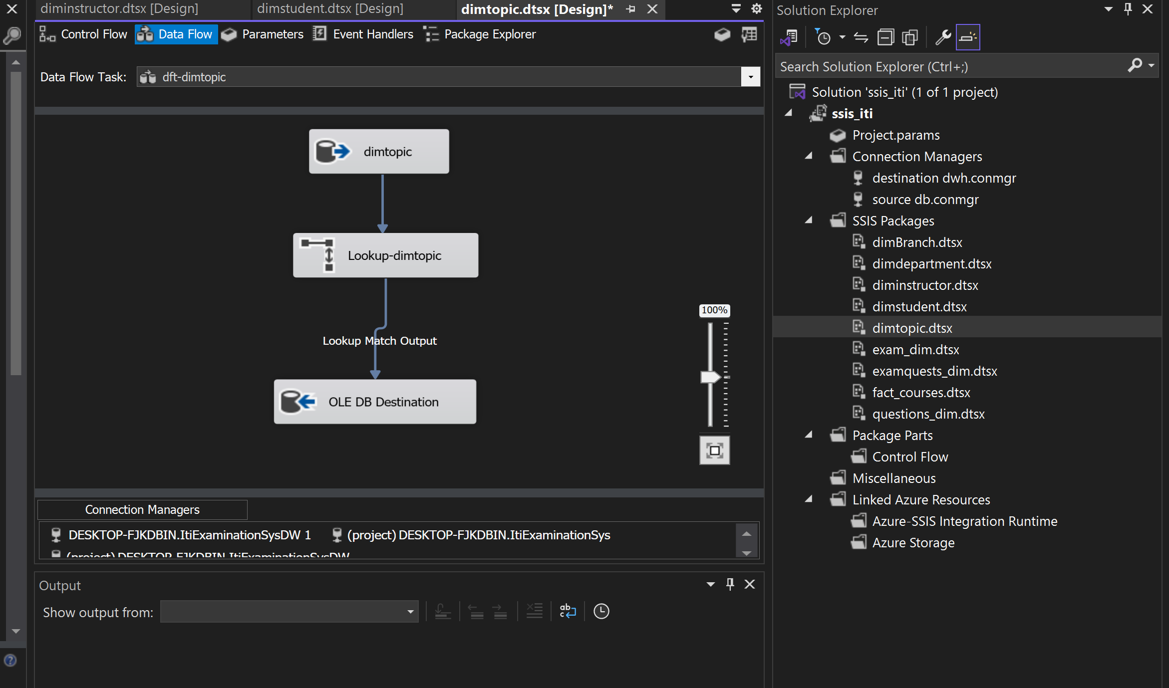

**Power BI Dashboards**

First, **ETL Process for Power BI Model (Modeling Layer):**

We completely redesigned the data model in this phase to ensure more accurate and reliable insights. This involved importing all the necessary tables from the database and properly managing them within the staging area, divided into partition source and model reference.

We organized and cleaned the data, performing transformations where needed. For example, we removed unnecessary spaces, adjusted Capital letters, and added essential columns, such as one that converts binary image data into text format, allowing Power BI to handle it correctly.

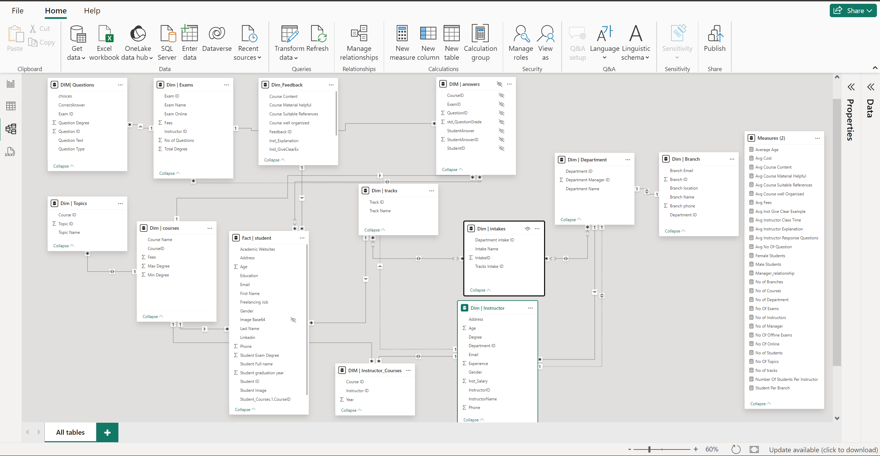We also redefined the relationships between the tables, ensuring they were set up correctly to support accurate analysis. This step was crucial because the relationship structure directly impacts the values of the measures used in Power BI, including aspects like participation and the direction of relationships.

**Navigation Dashboard**: The first dashboard which contains the most important topics that we will cover through the upcoming dashboards.

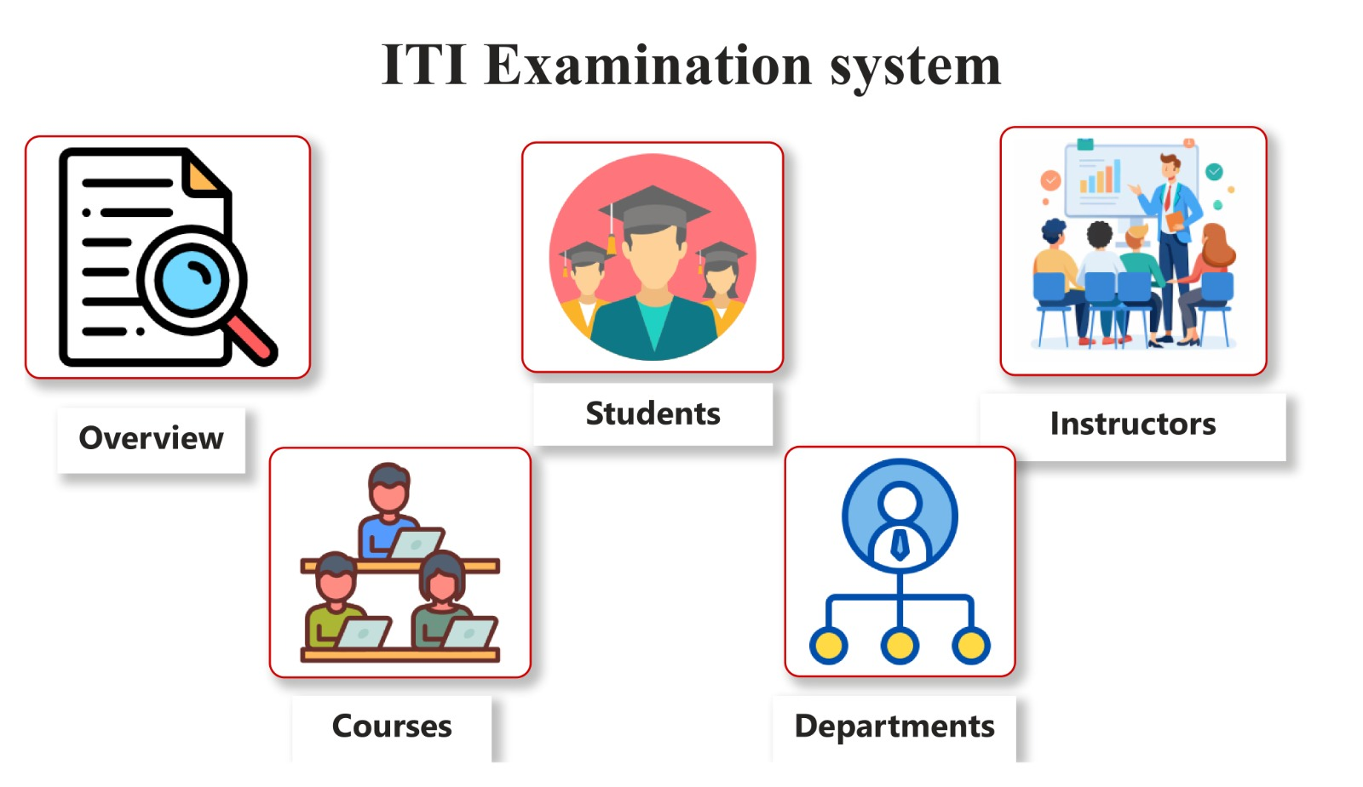

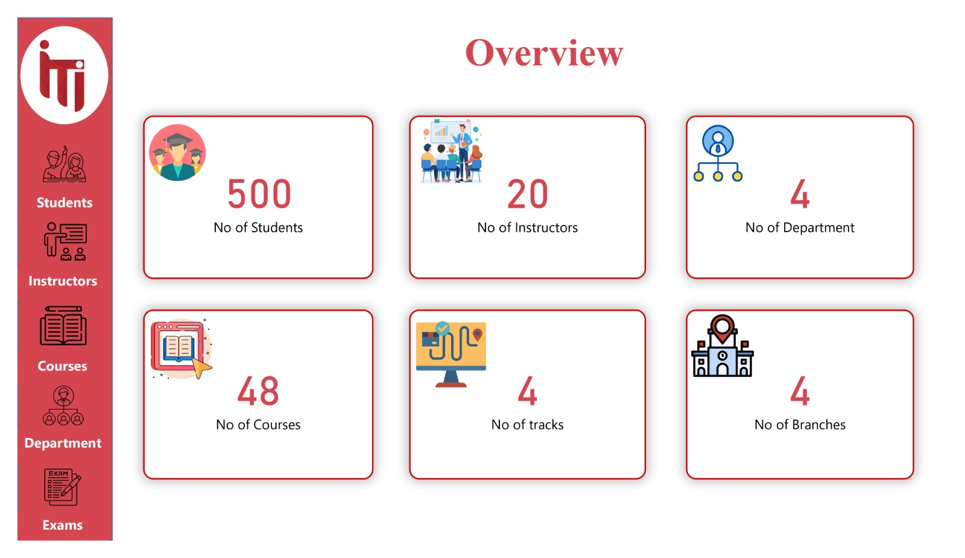**Overview Dashboard:** Analyze the examination system as a whole and explain the numbers of Students, numbers of Instructors, numbers of Departments, numbers of Courses, numbers of Tracks, and numbers of Branches.

Second **Overview Dashboard:** Explain the numbers of Instructors by their Department, The Distribution of Students' Grades, and the number of Students by Course and Track Name.

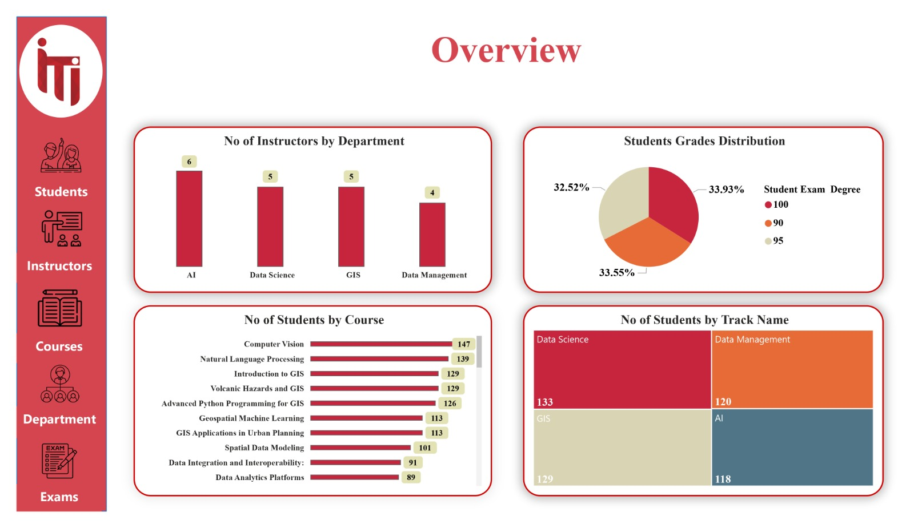

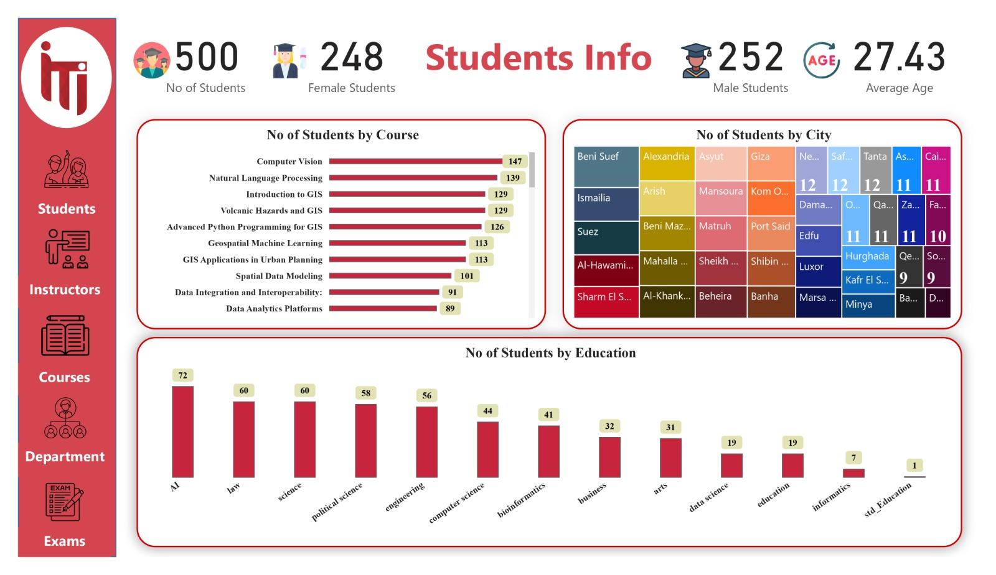**Student Info Dashboard:** Show the Distribution of Students by City, numbers of Students by Course and Education.

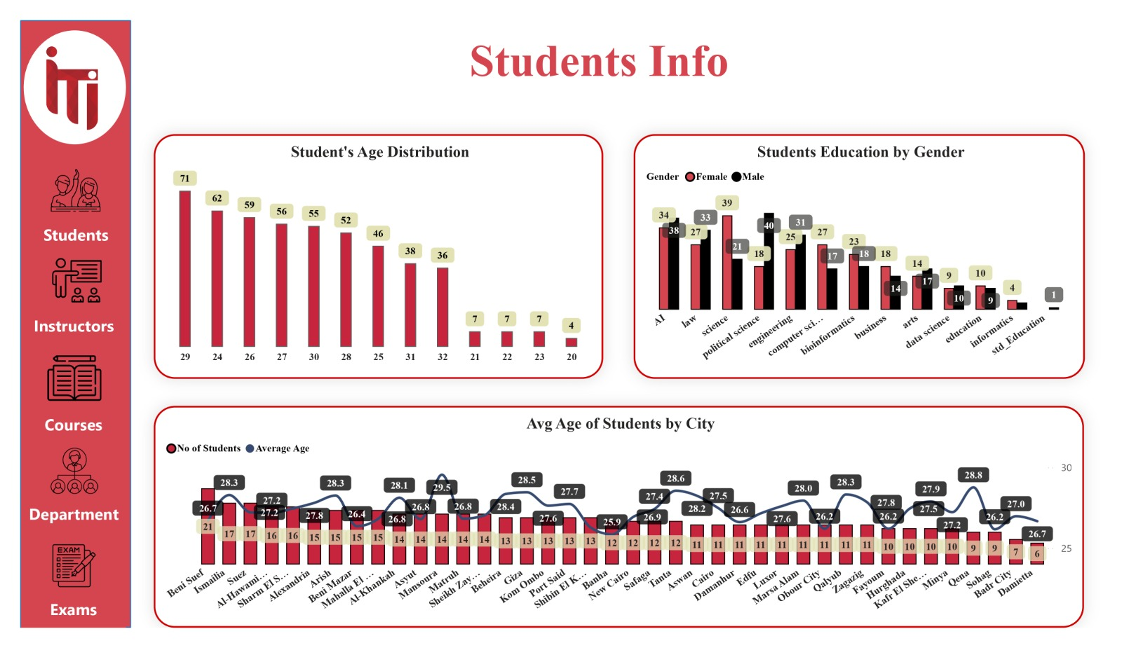Second **Student Info Dashboard:** Show the Distribution of Students by their Ages, Student Education by Gender, and Average Age of Students by City.

**Students by Track Dashboard:** shows the number of Students per Track by Gender and the Average Age of Students by Track.

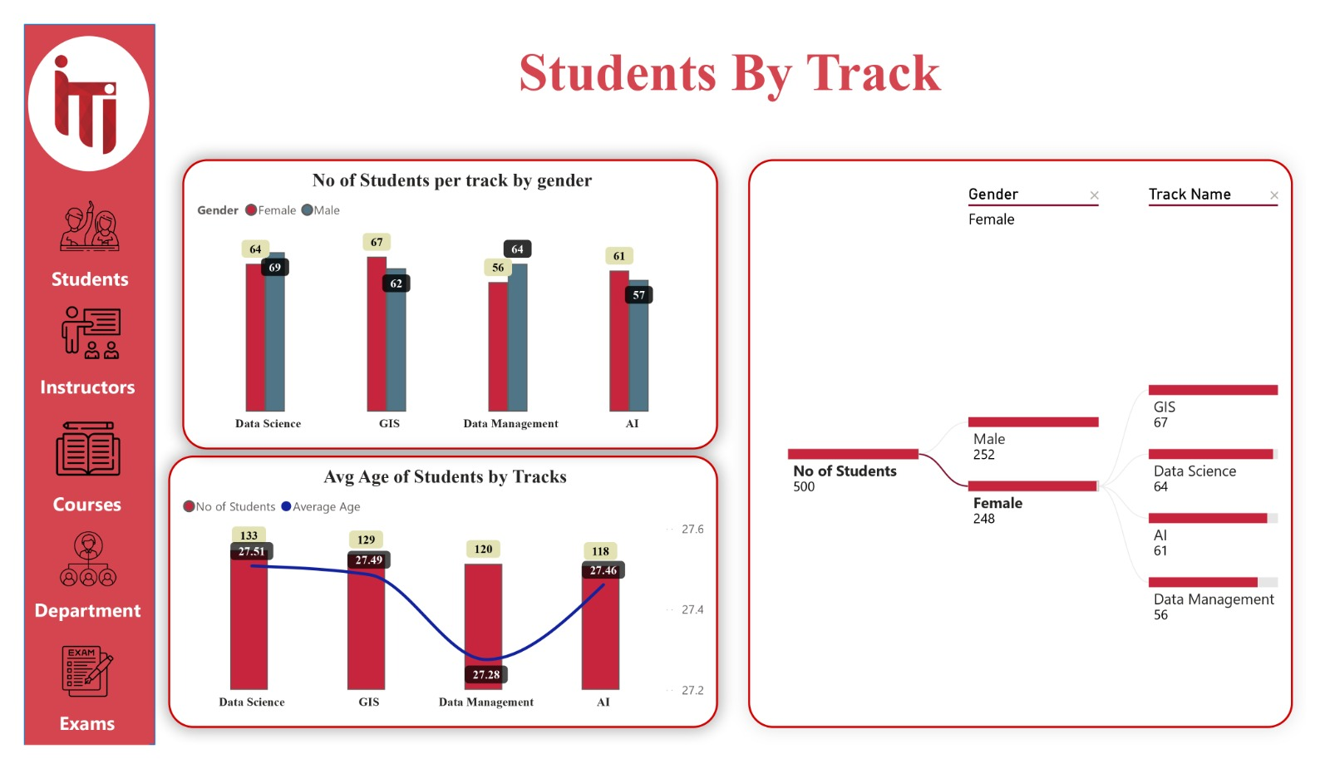

**Student Distribution Over Cities Dashboard:**

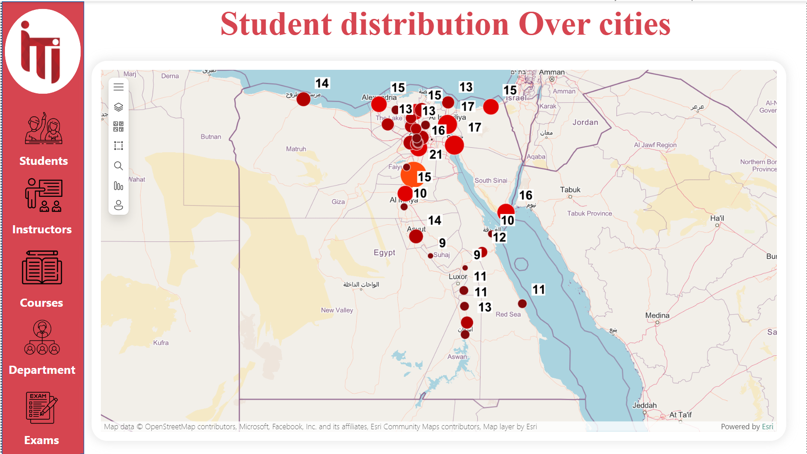

**Student Distribution Over Cities by Details: Shows the top 5 Cities with the Highest training Enrolments and Percentage distributions of Student Gender.**

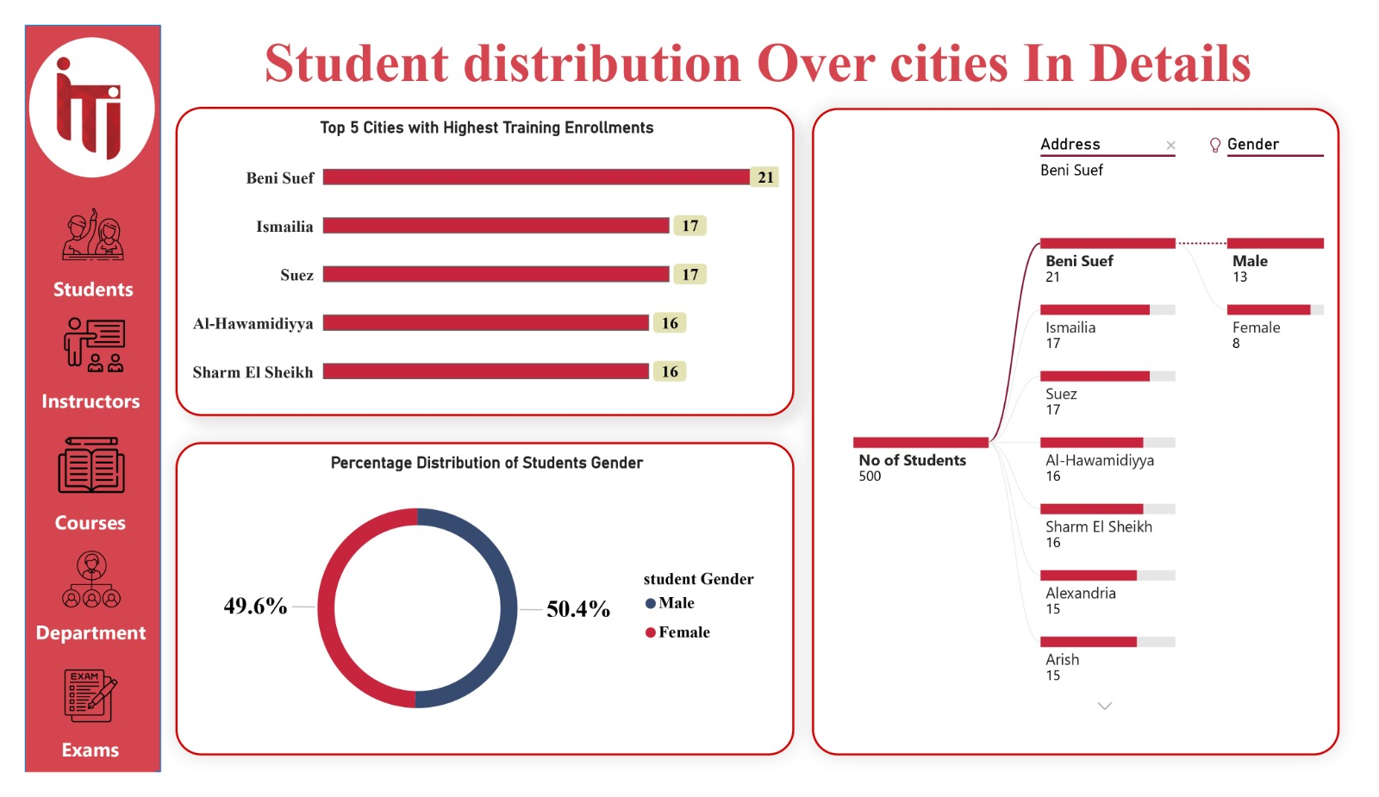

**Student Grades Dashboard:** Shows the Student Name, Course Name, Student Degree, and the Top 10 Students Avg Score Per Track.

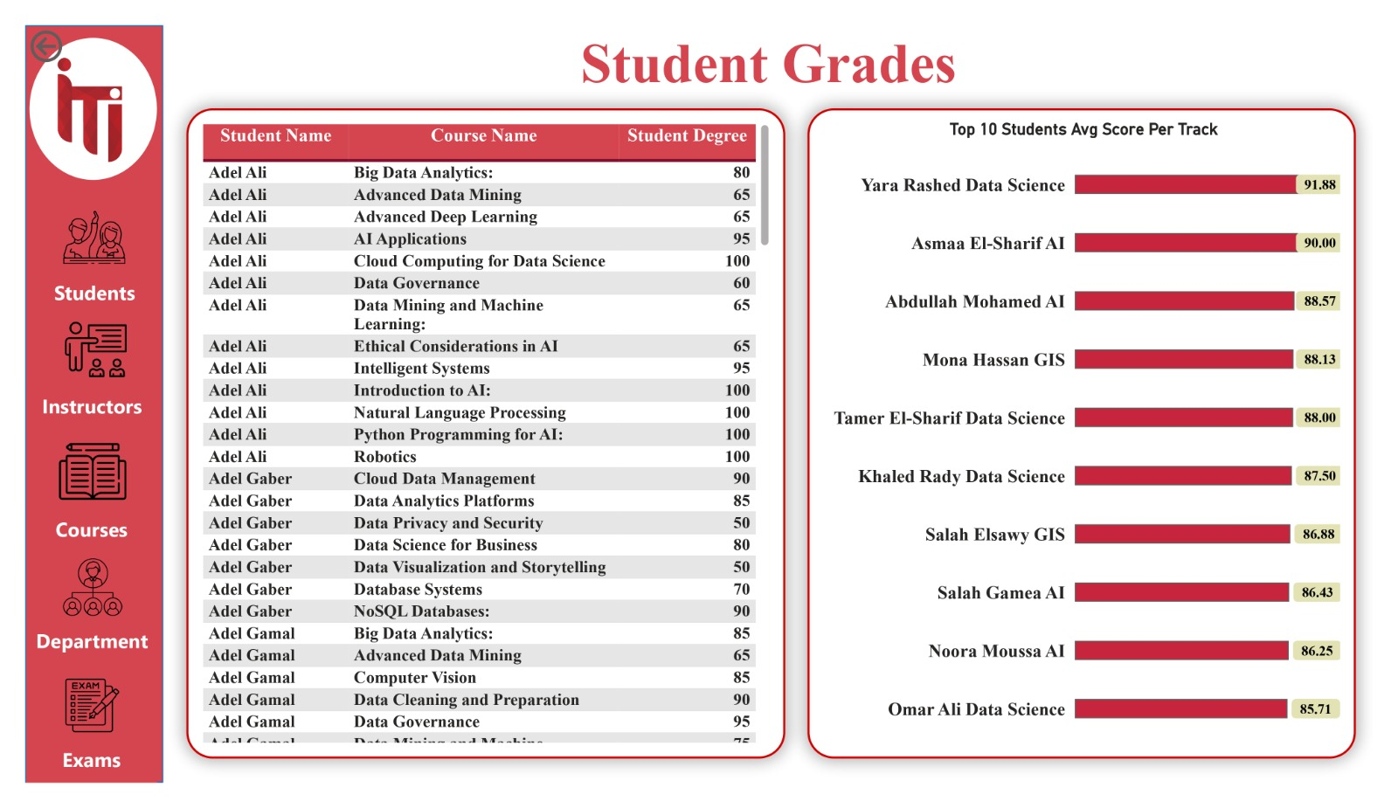

**Freelance Performance Dashboard:** Shows Each Track and Freelance Performance in it and Compares males and females in completing freelance jobs.

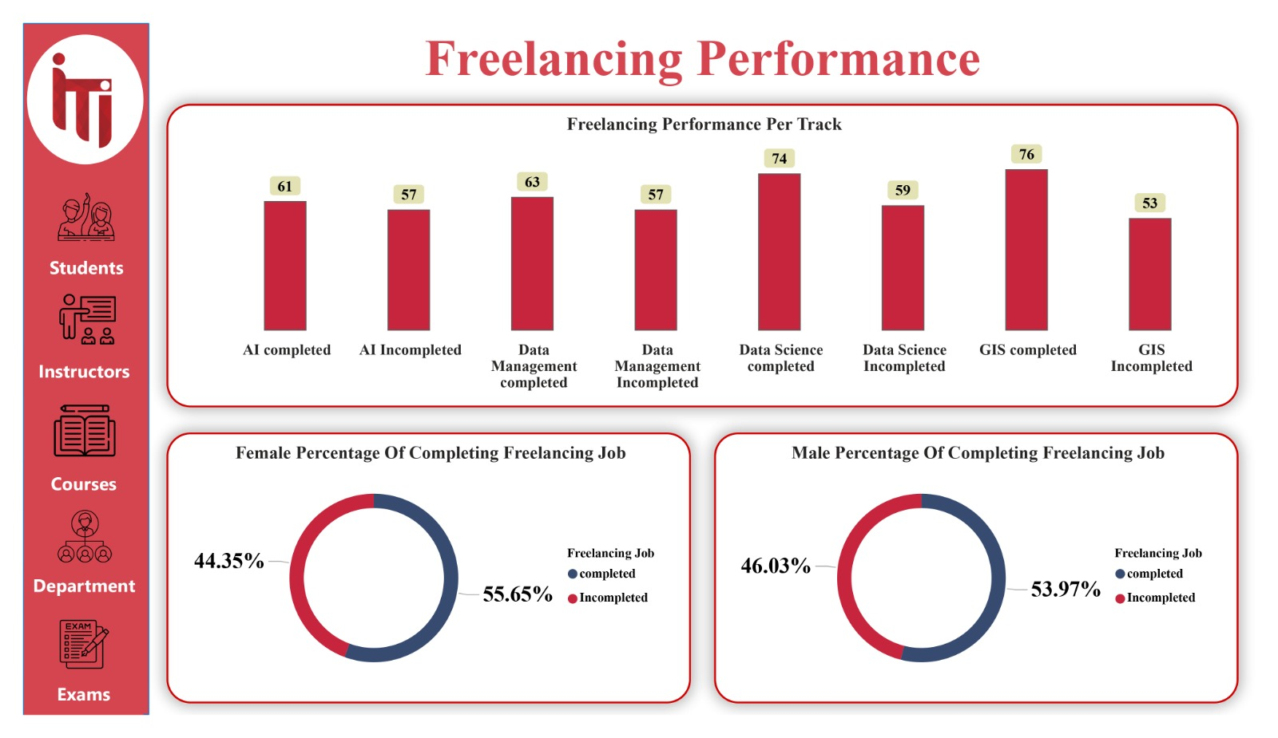

**Online Certificate Dashboard:** Shows the Distributions of Certificates by Track, and Compares the three most common Academic Websites (Coursera, Udemy, and DataCamp).

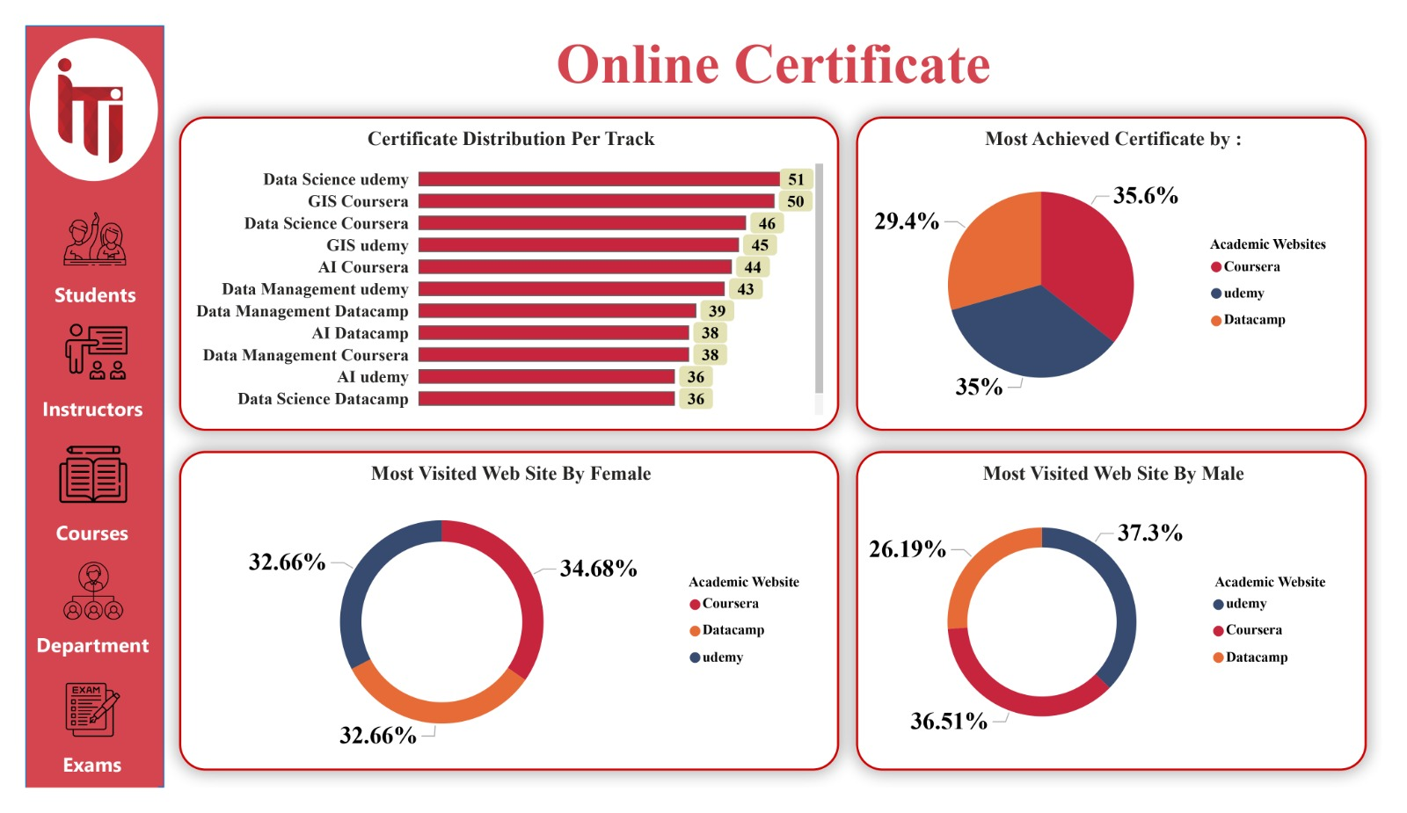

**Student Assessment Dashboard:** shows Student details like his name, Track, City, and the link to his LinkedIn profile and his grades per his Courses.

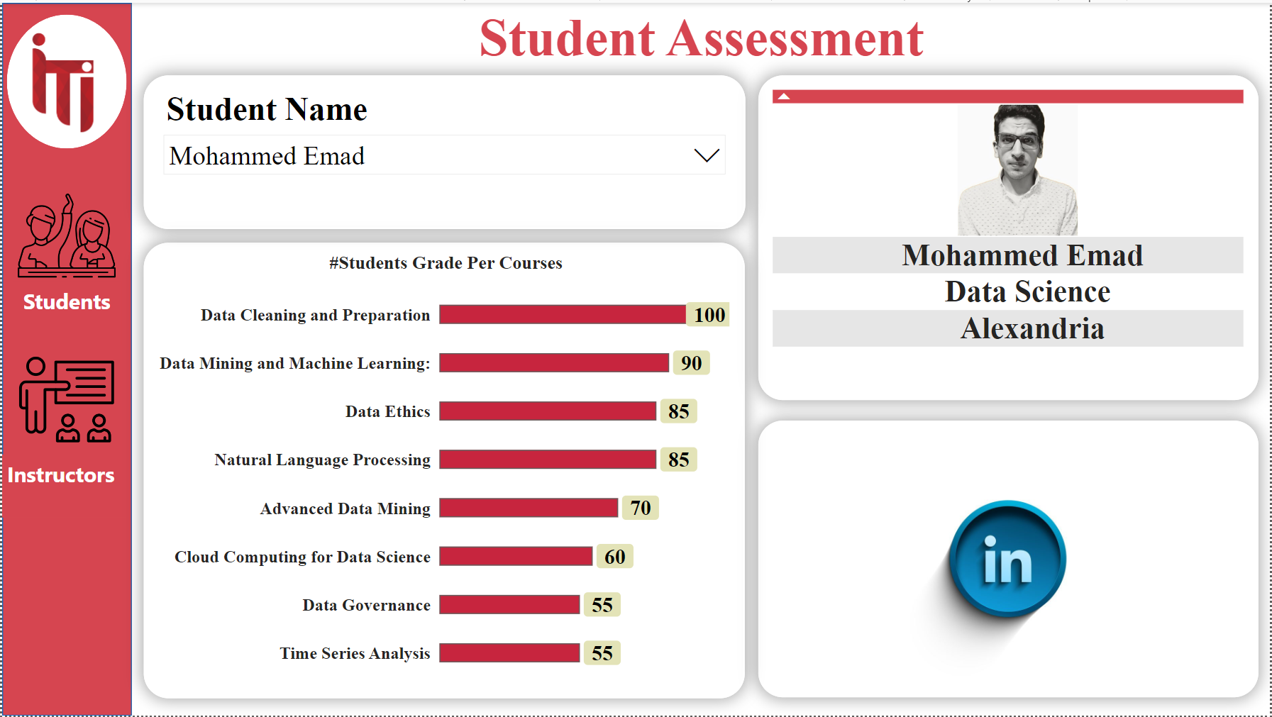

**Student Details Dashboard:** Shows all the Details of each Student (StudentID, First Name, Last Name, Gender, Age, Address, Track)

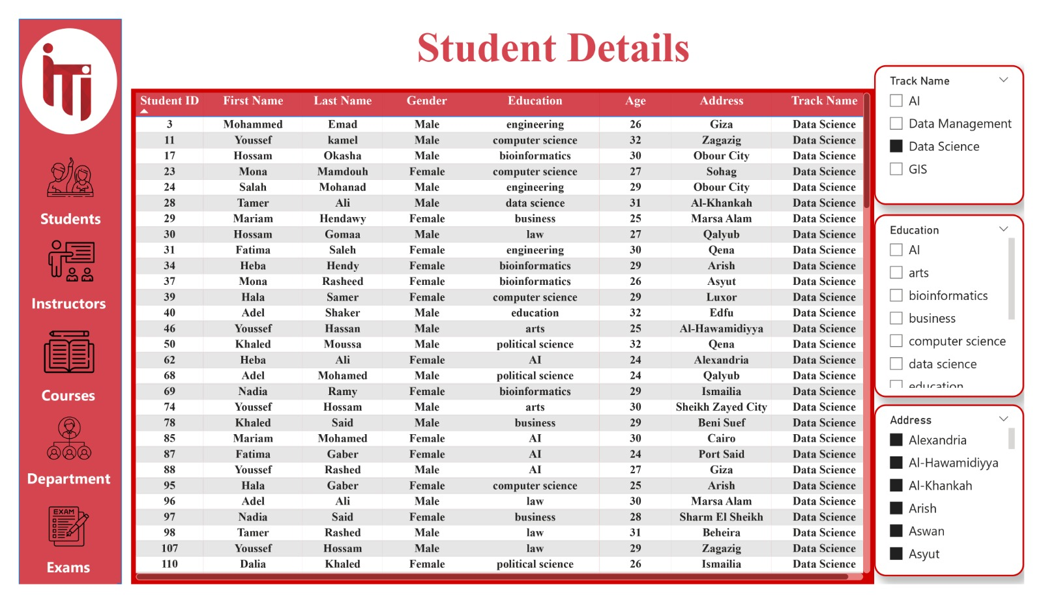

**Instructors Overview Dashboard:** Shows the Number of Instructors by City, Instructor’s Degree, and Average Salary by Age.

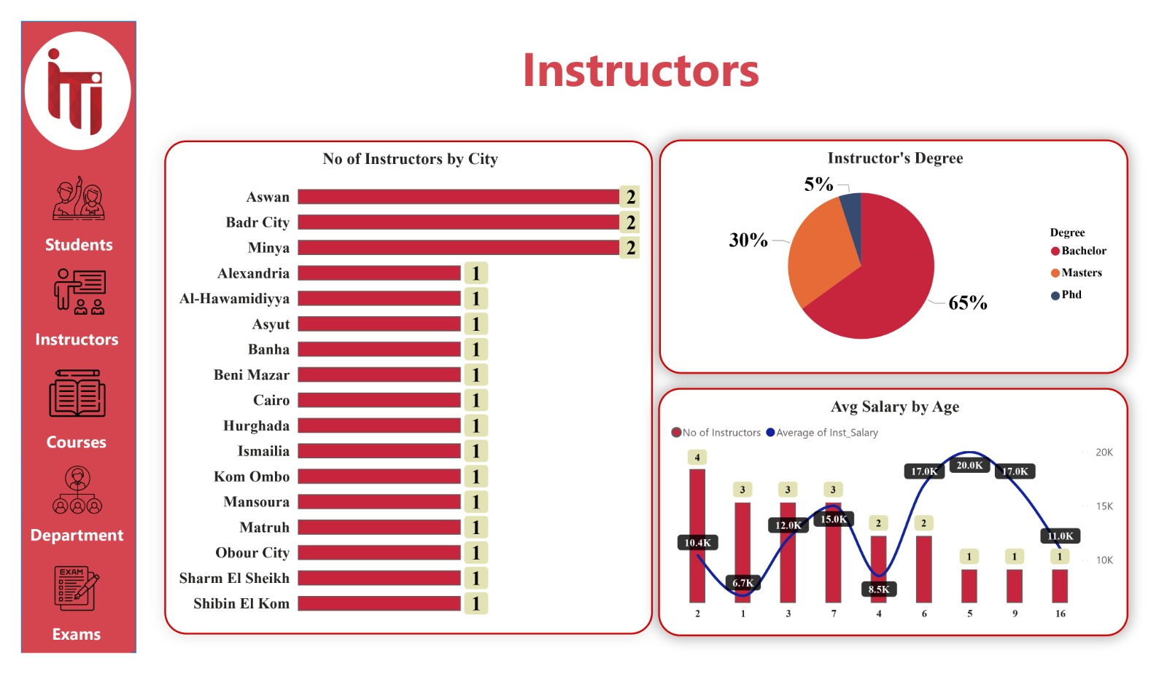

**Instructors Dashboard:** Shows average salary by Degree, Number of Students per instructor, and top Instructors by Salary.

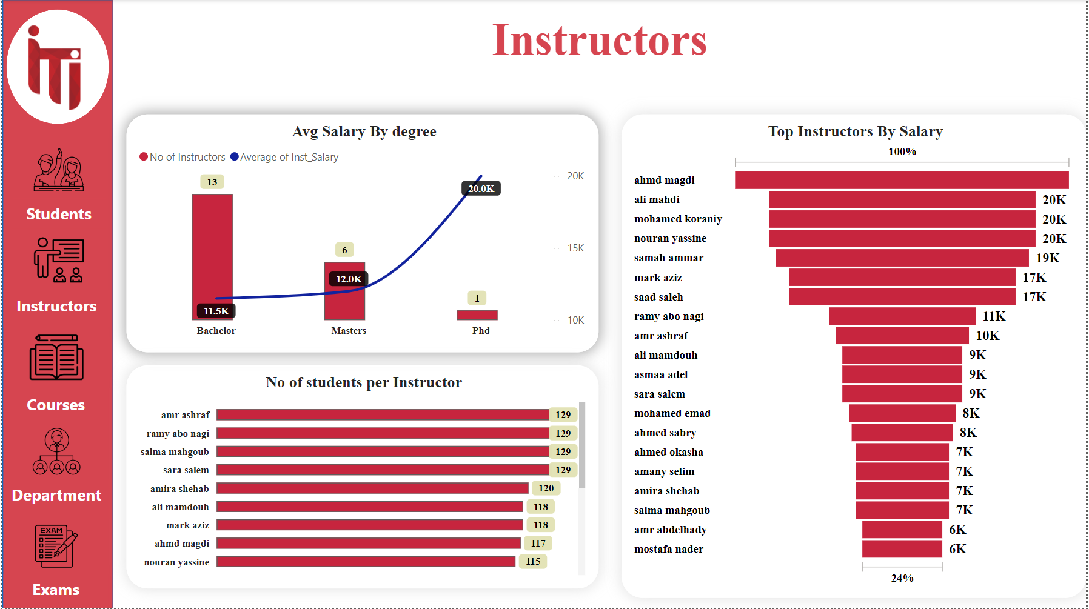

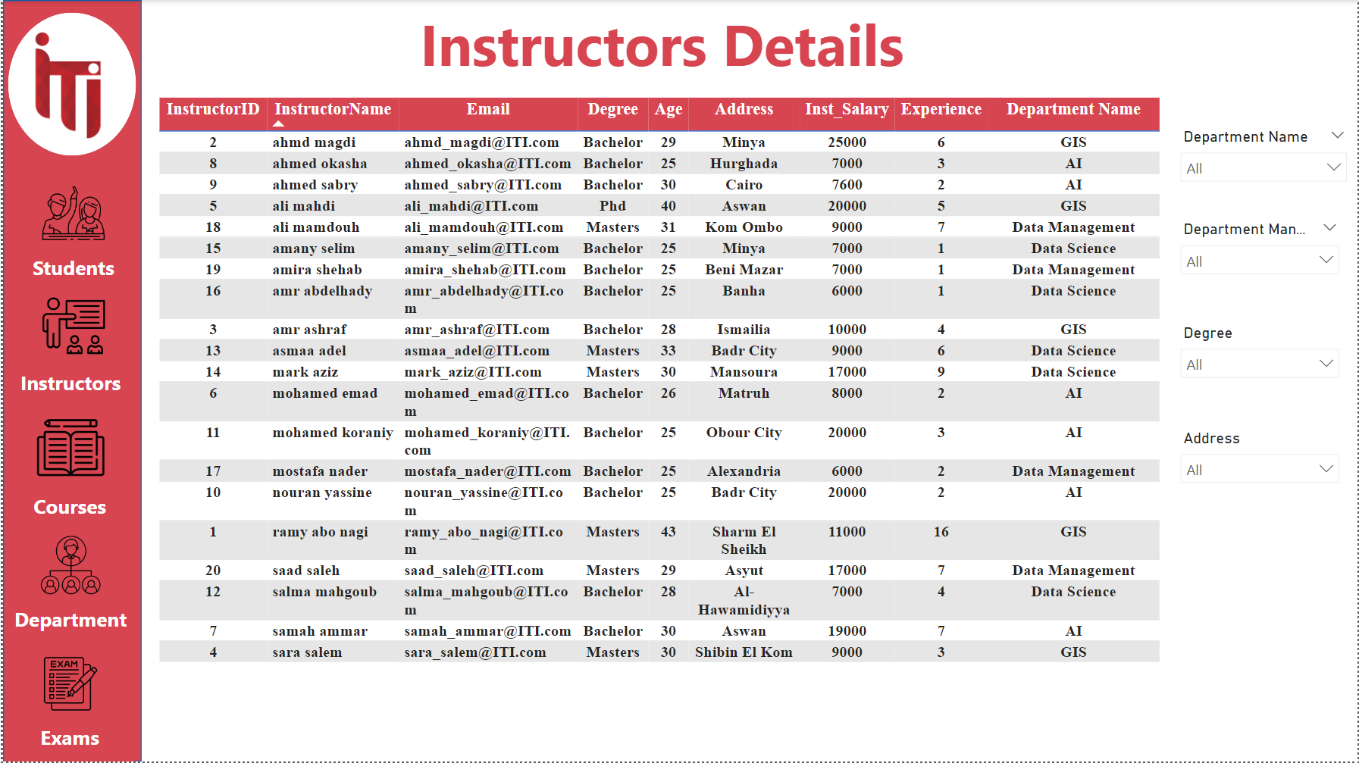**Instructors Details Dashboard:** Shows all information about each Instructor (InstructorID, Name, Email, Degree, Age, address, Net Salary, Department Name)

**Instructors By Department Dashboard:** Shows the Numbers of Instructors by Department, Years of Experience, and Number of Courses by Instructor Name.

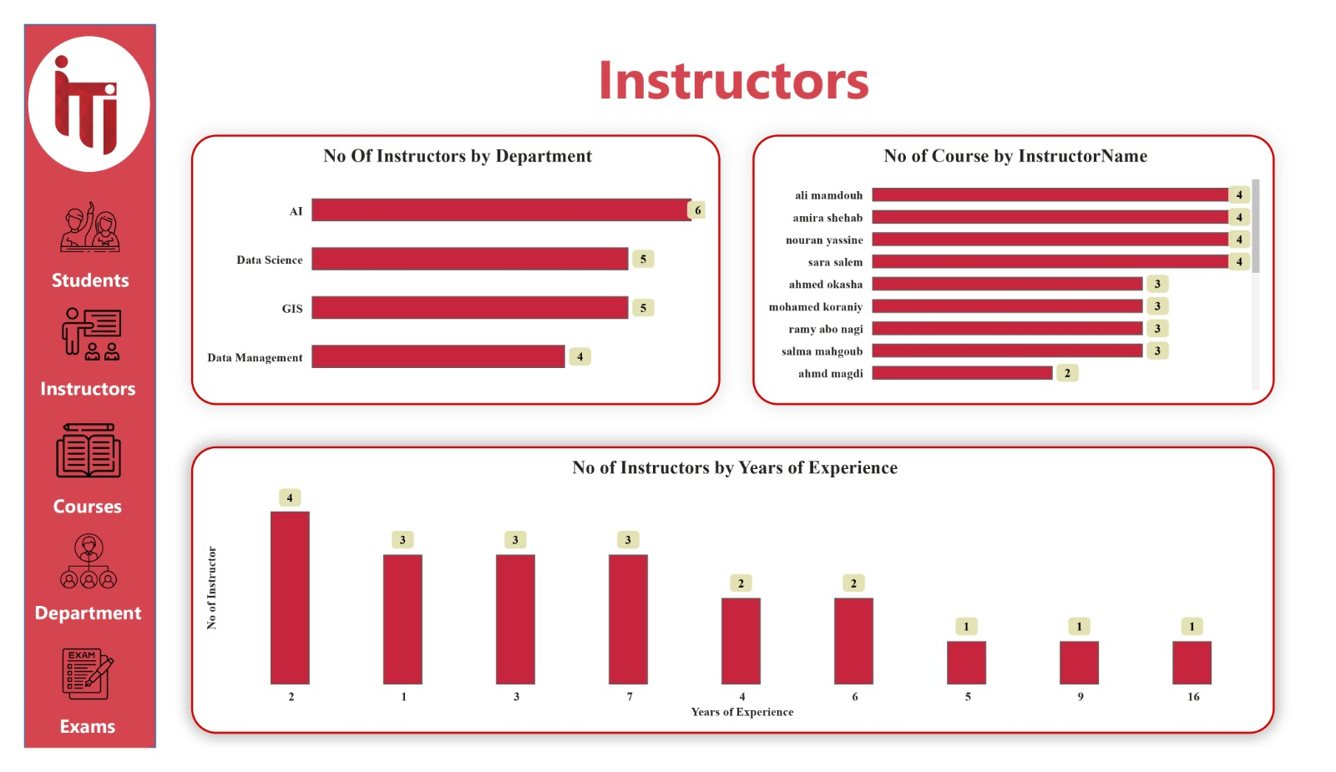

**Instructors Feedback Dashboard:** Shows the Feedback of the Students to their Instructor According to (Instructor's Response , Instructor Clear Example, and Instructor Explanation).

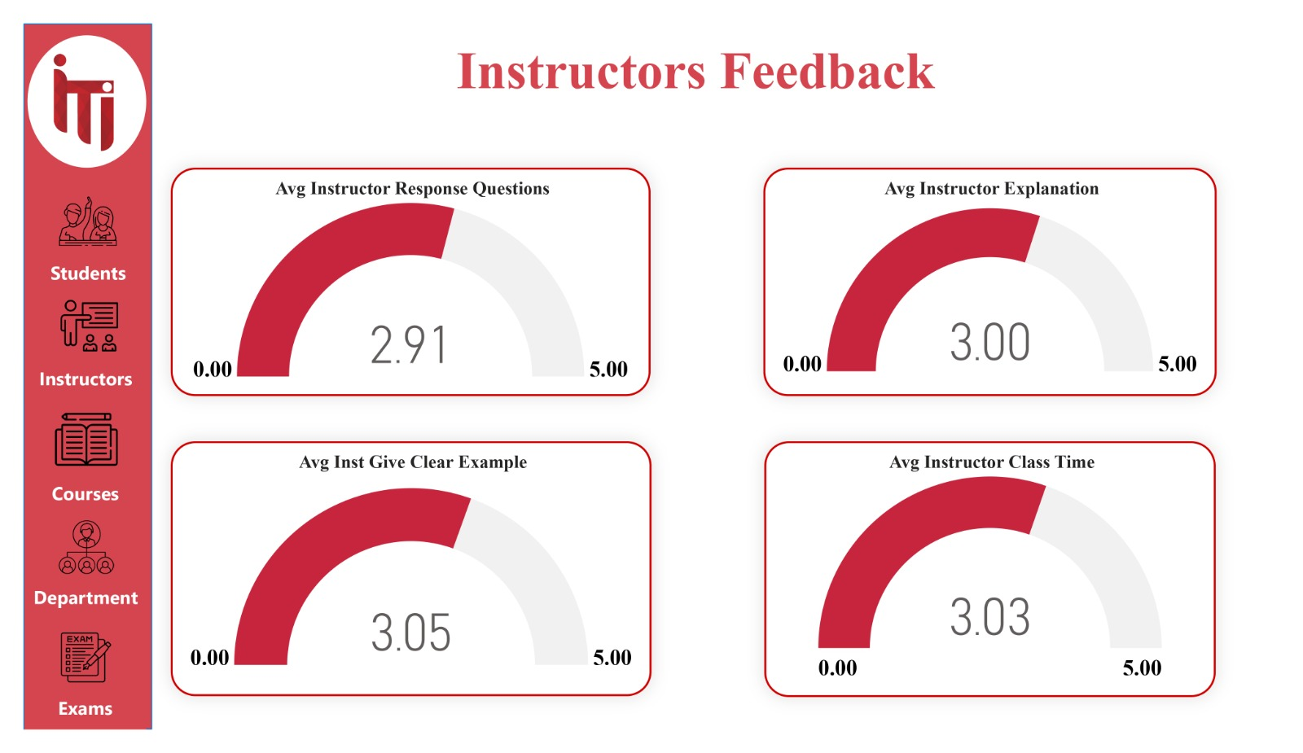

**Course Dashboard:** Shows the Number of Courses, Average Fees, Number of Students by Course, and Fees for Each Course.

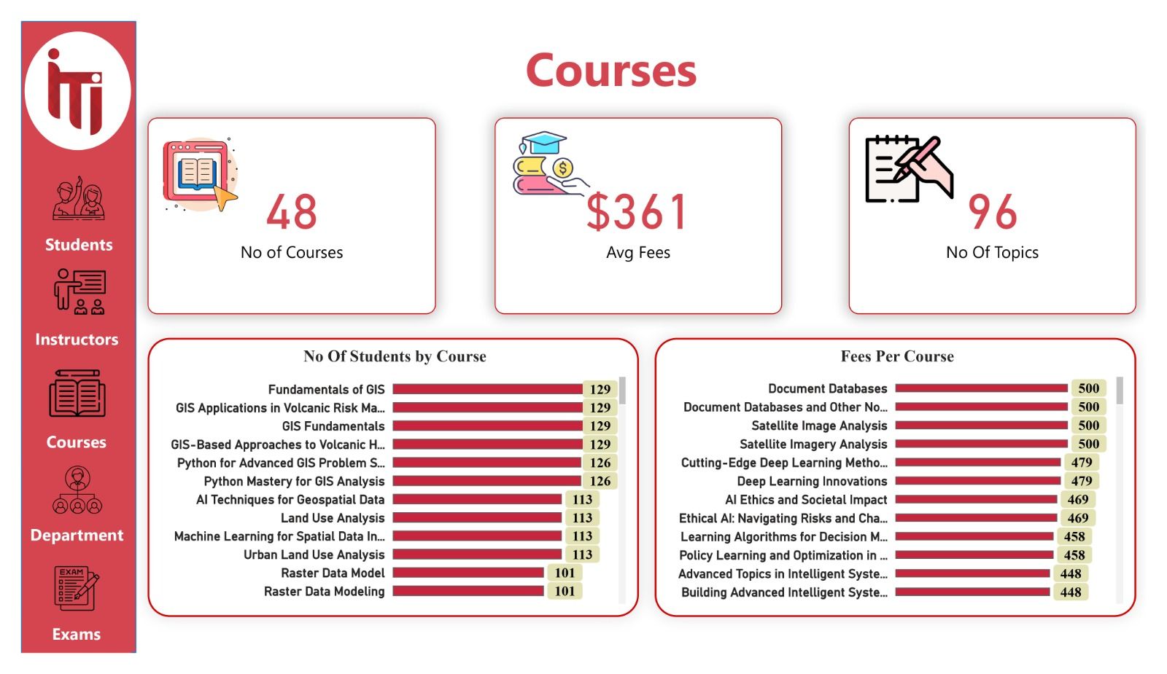

**Courses Feedback Dashboard:** Shows the Feedback of the Students on their Courses According to (Course Material, suitable References, Content, Well Organized).

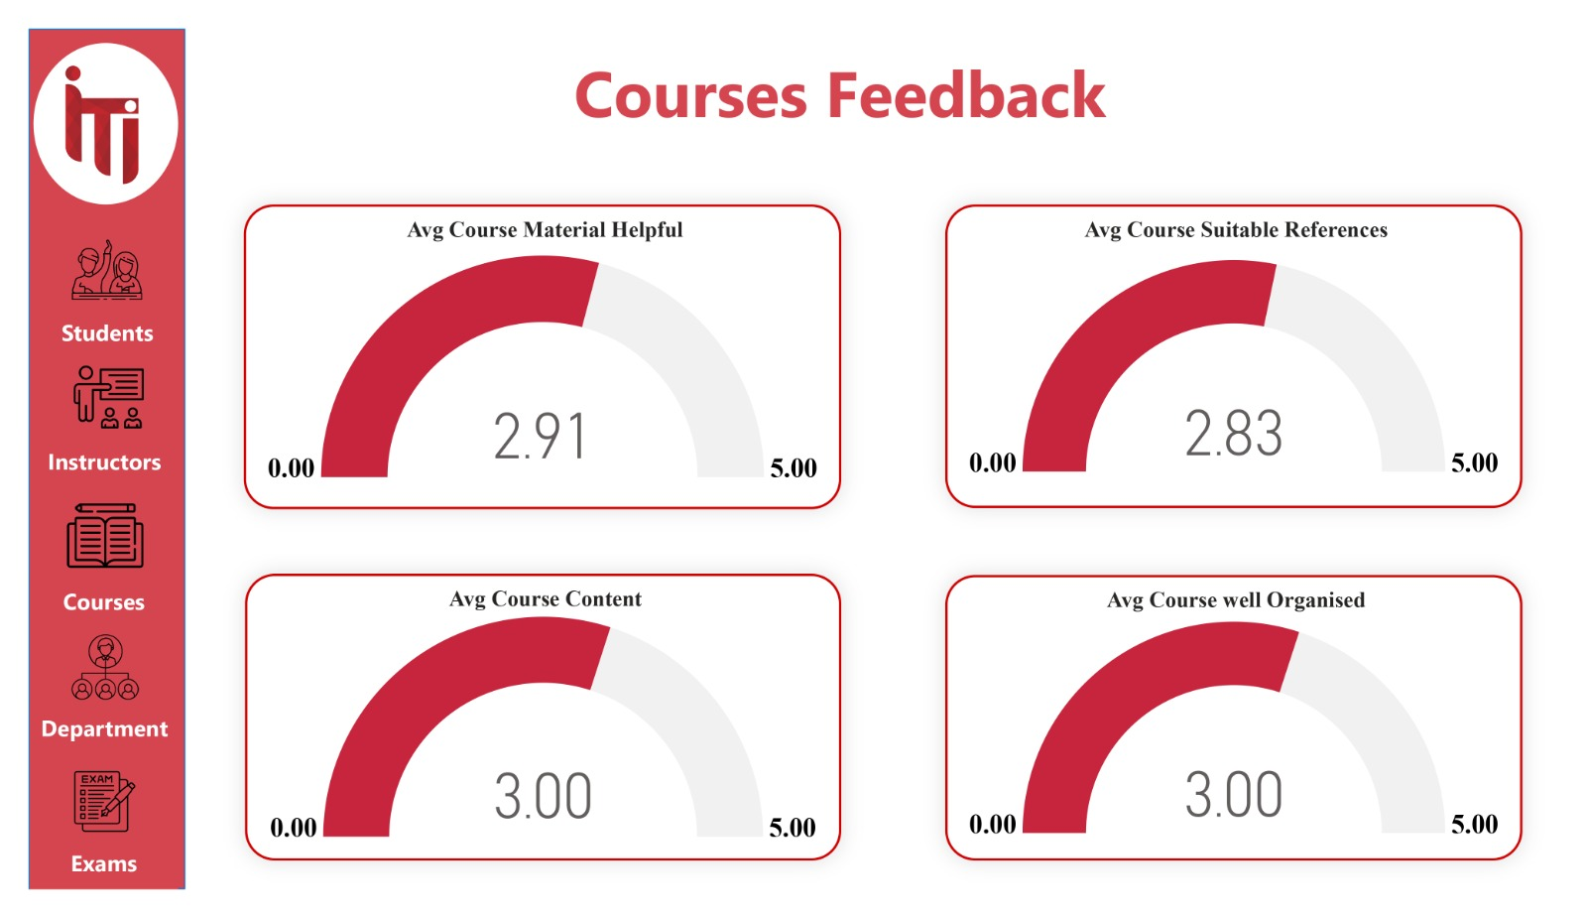

**Course Details Dashboard:** Shows all information about the Course (CourseID, Name, Fees, Topic Name, Min and Max Degree).

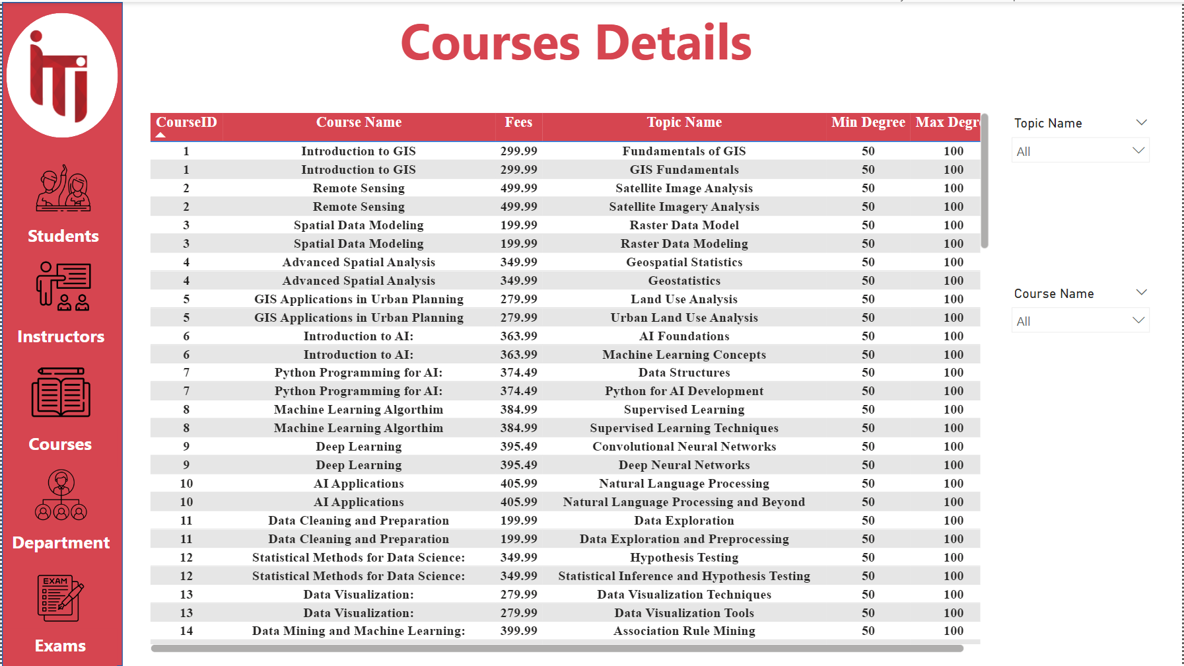

**Student Distribution Over Branches Dashboard:** Shows the Number of Students in each Branch and Student Percentage per Department.

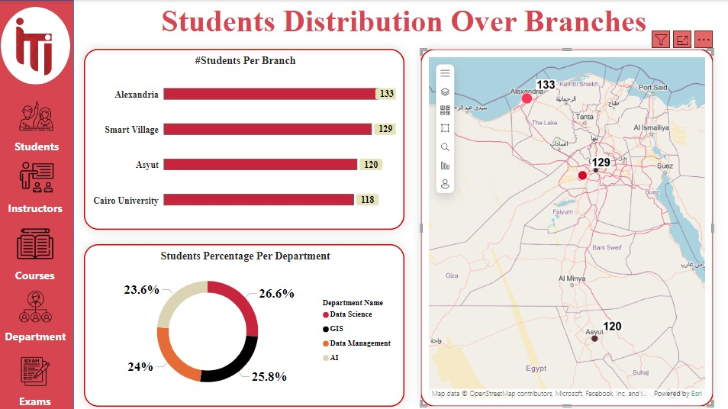

**Exams Dashboard:** Shows the Number of Exams, the average number of Questions in each Exam, Average Cost, Number of Students by Exam, and Fees by Exam.

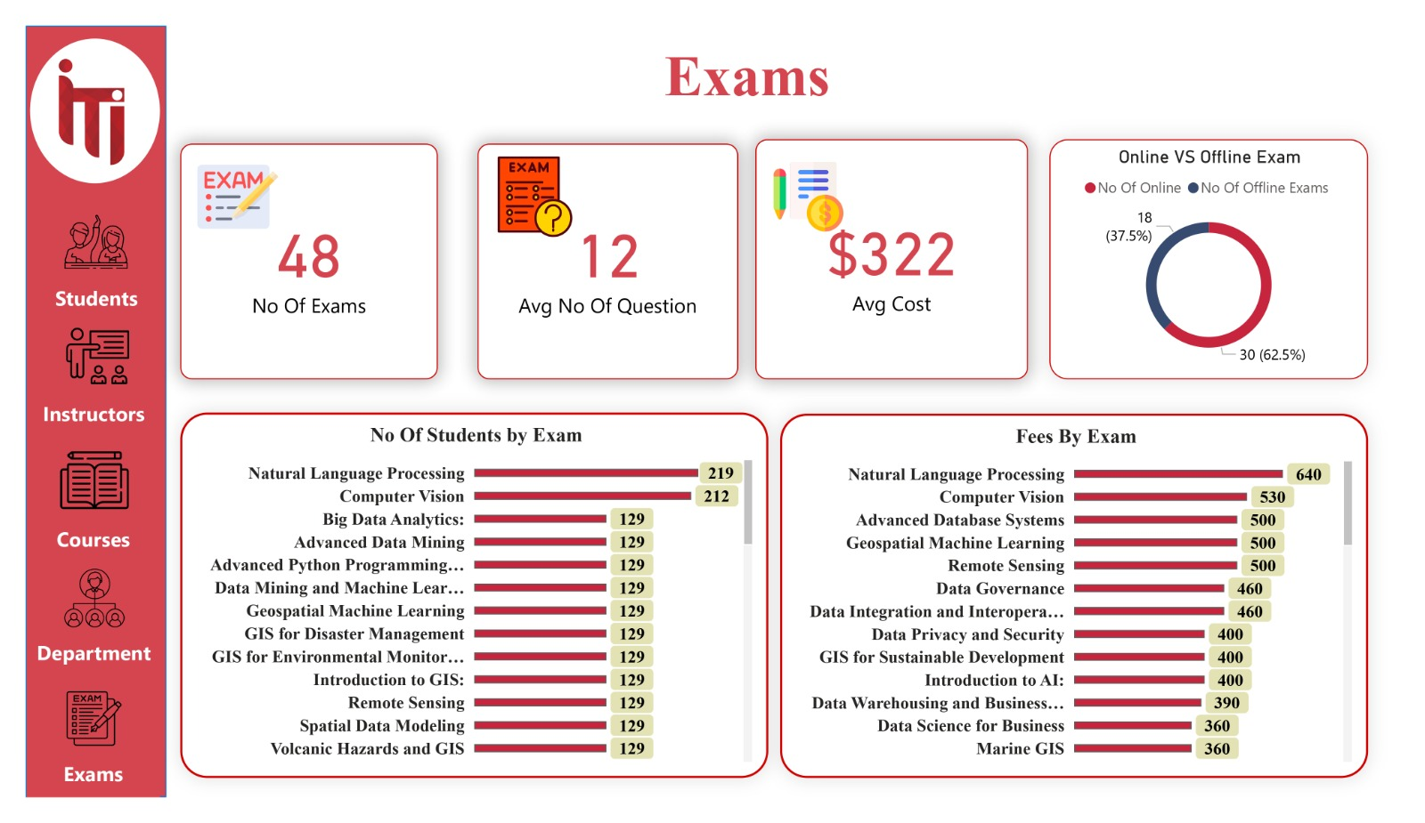

**Exam Details Dashboard:** Shows all the Information about the Exam (ExamID, Name, Online or Offline, Fees, Number of Questions)

